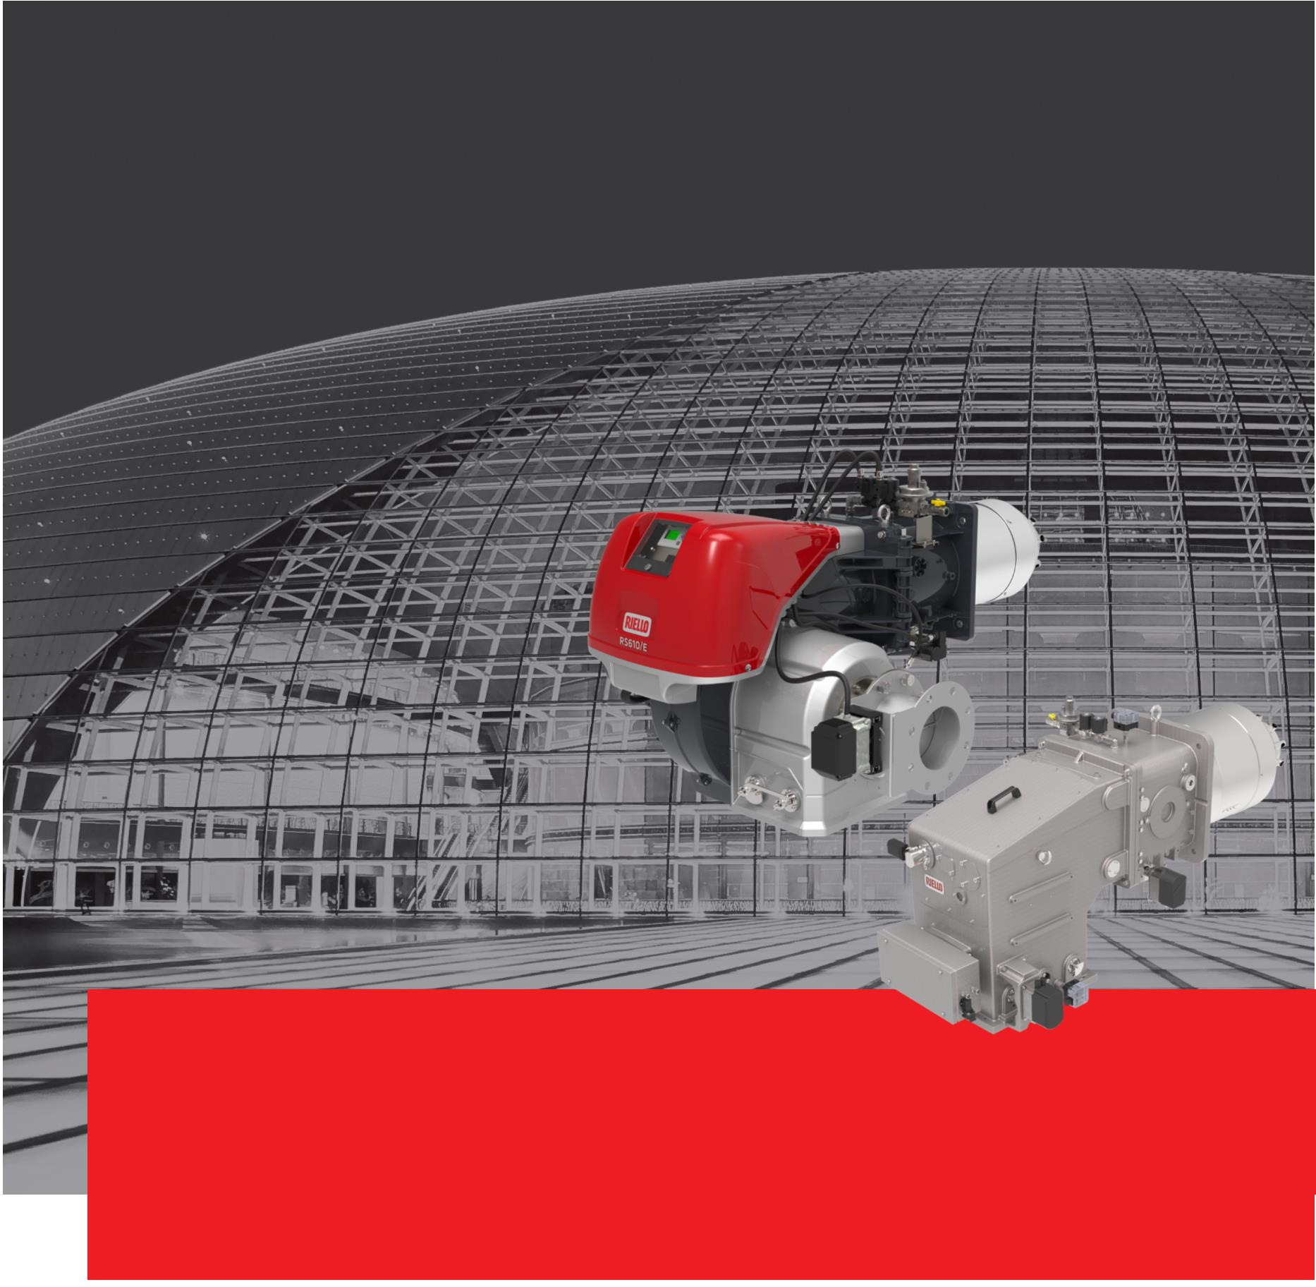RS/E FGR - DB SE FGR Series
Monoblock and Dual Block Gas FGR Burners
Ultra Low NOx Gas Burners - NOx < 30 mg/kWh
Product Overview
www.riello.com
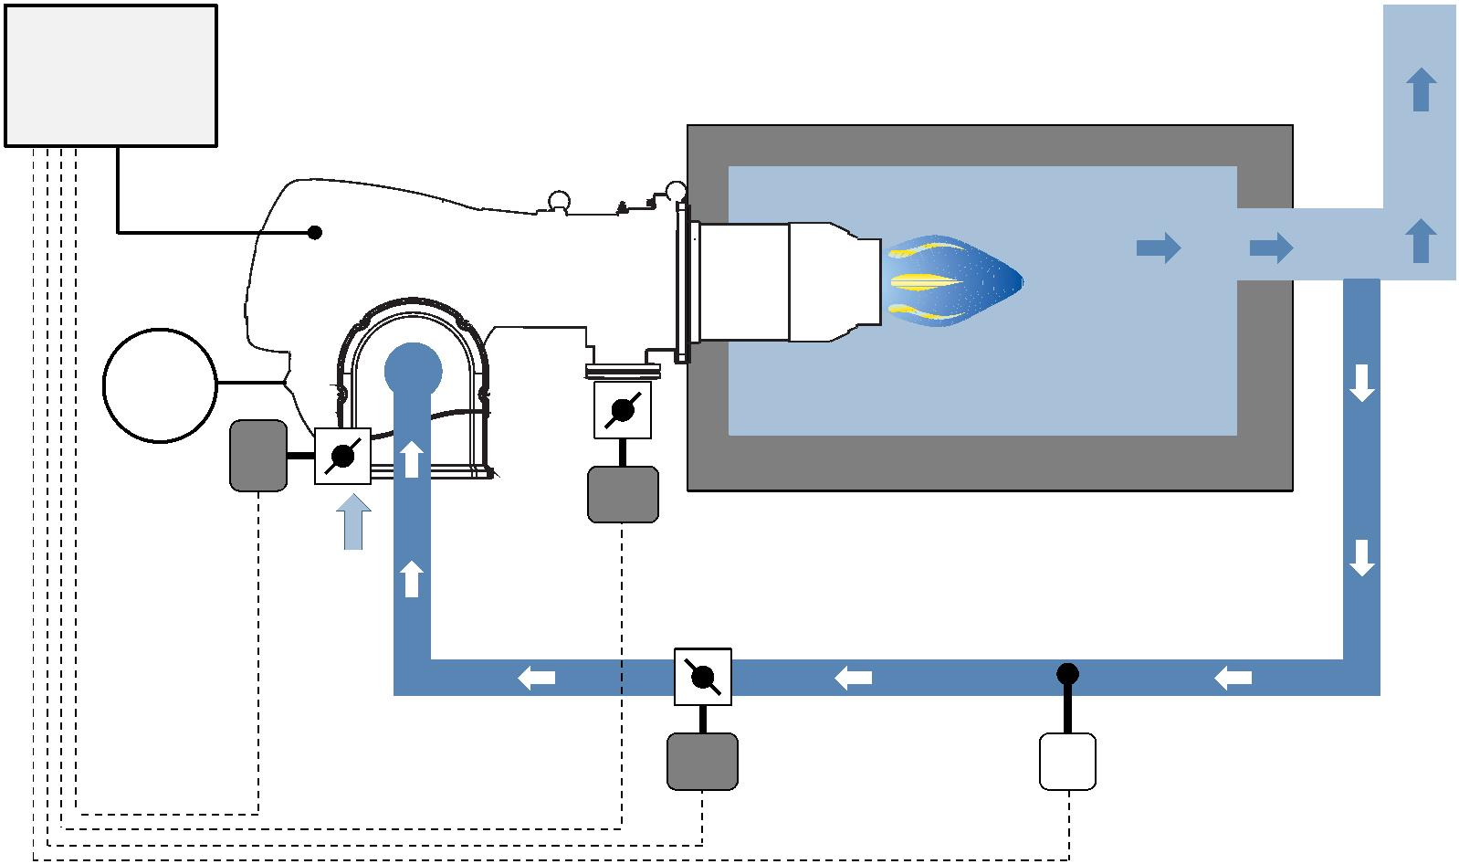Monoblock and Dual Block Gas FGR Burners
FGR Technology
Due to the significant increase of pollutants in these last years, attention to performance, energy efficiency and
emission reduction is becoming more important all around the world, in particular in all the highly industrialized
countries.
In order to comply the increasing demand of very low NOx emissions, RIELLO has developed a new range of
Monoblock and Dual Block burners equipped with advanced Low NOx combustion heads and with the FGR (Flue
gas Recirculation) low emission technology, which are suitable to achieve the most restrictive emission limits.
FGR technology is based on the recirculation of a part of the exhaust gas, which is introduced in the air inlet side
of the burner; an integrated Digital Burner Management System, through the action of independent servomotors,
allows the control of air, fuel and exhaust gas proportion in every working point, in order to reach very low NOx
emissions, while maintaining high reliability and safety of operation.
ꢃꢄsꢁeꢅ
ꢆonꢁrol
 | ꢇꢂr  acꢁuaꢁor |  | ꢇꢂr  suꢊꢊlꢄ |  | Gas  acꢁuaꢁor
 |  |  |  |  |  | ꢇuꢉꢂlꢂarꢄ  acꢁuaꢁor |  |  | ꢈ |  | ꢈeꢅꢊeraꢁure  conꢁrol
2
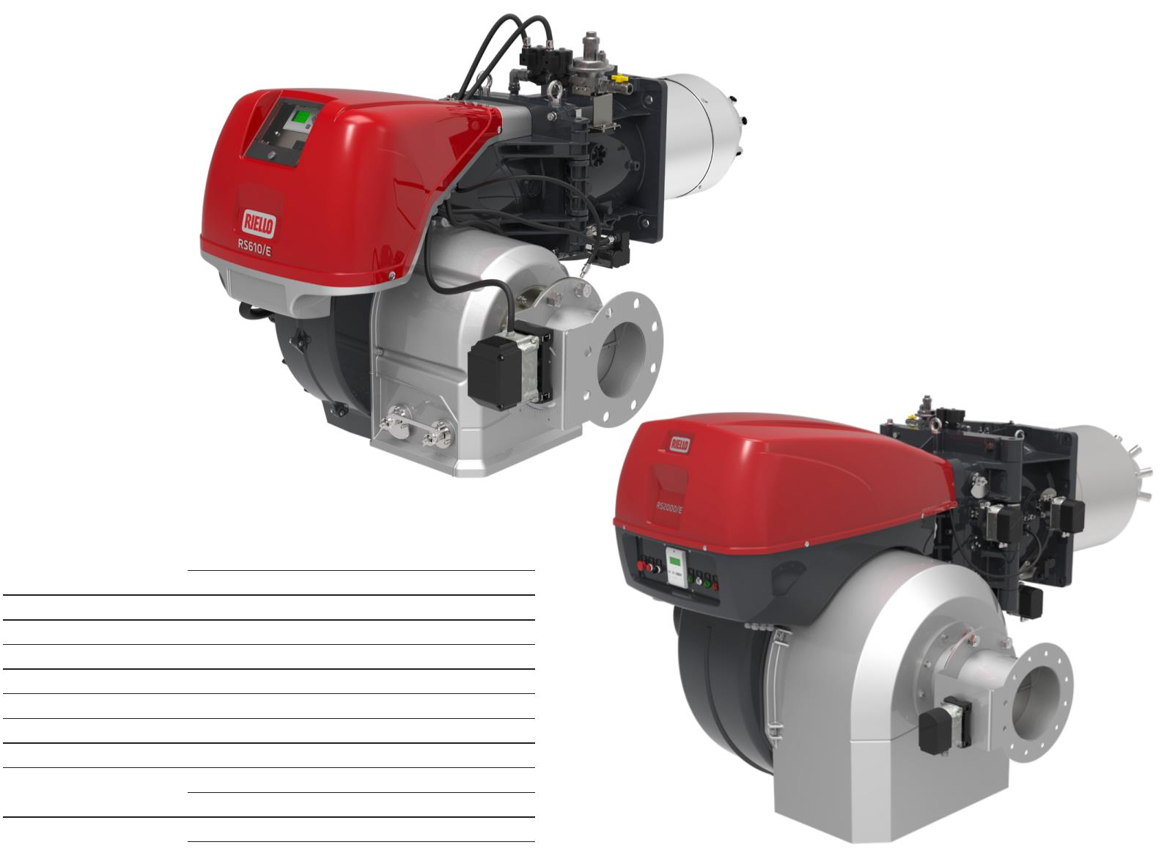Ultra Low NOx Gas FGR Monoblock Burners
RS 68÷2000/E FGR SERIES
With many years of experience in the design and manufacture of Burners, Riello has developed a new range of
Commercial and Industrial products, the New RS/E FGR Series, based on FGR (Flue gas Recirculation) low emission technology, suitable to achieve extremely Low NOx emission performance, lower than 30 mg/Nm³ @ 3.5% O₂.
The RS/E FGR burners series operation is based on a Digital Burner Management System, which is able to manage the air-fuel ratio by independent servomotors in order to obtain a perfect output control and to assure a correct
low polluting combustion and a safe operation on all modulation range.
The monoblock configuration allows having all the components integrated in a compact size, in
order to facilitate and make extremely easy the installation and maintenance.
BURNER MODEL
RS 68/E FGR 195 ÷ 350/810 kW
RS 120/E FGR 300 ÷ 595/1150 kW
RS 160/E FGR 350 ÷ 958/1849 kW
RS 200/E FGR 550 ÷ 1372/2300 kW
RS 310/E FGR 400 ÷ 1200/3630 kW
RS 410/E FGR 500 ÷ 1500/4450 kW
RS 510/E FGR 680 ÷ 1800/5250 kW
RS 610/E FGR 1000 ÷ 2200/6250 kW
RS 800/E FGR 1200 ÷ 3500/7000 kW
RS 1000/E FGR 1100 ÷ 4000/10100 kW
RS 1200/E FGR 1500 ÷ 5500/11100 kW
RS 1300/E FGR 2500 ÷ 7500/13000 kW
RS 1600/E FGR 3065 ÷ 9503/15560 kW
RS 2000/E FGR 4000 ÷ 12000/19500 kW
3
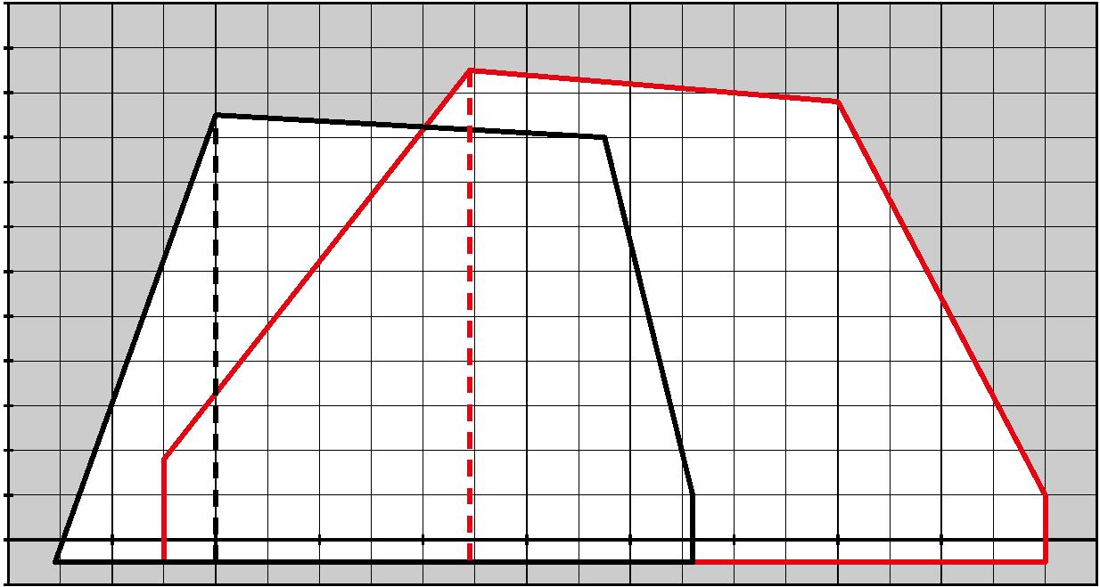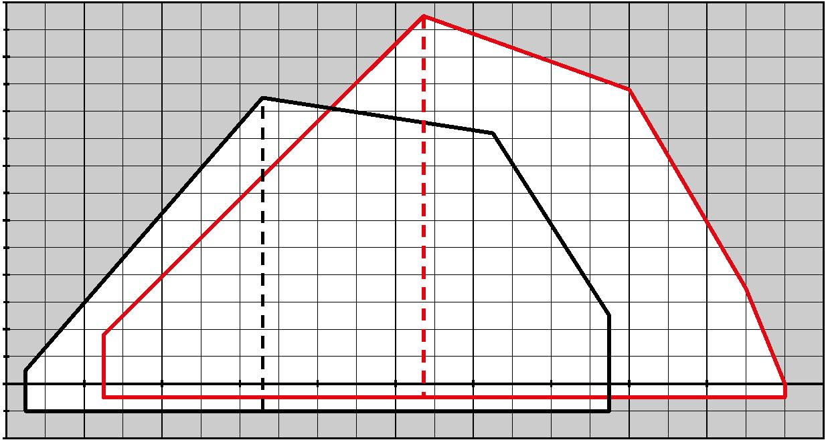Monoblock and Dual Block Gas FGR Burners
Firing Rates
Please note: it is important to be aware that the use of the Flue Gas Recirculation (FGR) function, in order
to achieve an ULTRA Low NOx emission performance, might lower the burner’s maximum output, because the
maximum amount of combustion air that can be introduced will be reduced, and so the oxygen concentration.
The shown firing rates are obtained in special test boilers, according to EN 676 regulation and referred to a
Low NOx performance conforming to the Class 3 of EN676, with 0% of Flue Gas Recirculation; by increasing the
recirculation % in order to achieve an ULTRA Low NOx emission the burner’s maximum output will be reduced.
A Flue Gas Recirculation % needed to obtain an Ultra Low NOx performance of 30 mg/Nm³ will involve a maximum
output reduction of roughly 20%.
ꢁꢃ
 | ꢁꢁ  ꢁꢂ |  | Rꢋ ꢇꢉꢌꢍ FGR Rꢋ ꢁꢃꢂꢌꢍ FGR |  | Useful working field  for choosing the  burner
ꢊ
ꢉ
Modulation range
 | ꢈ  ꢇ  ꢆ  ꢅ |  | Test conditions  conforming to  EN676  Temperature: 20°C  Pressure: 1013,5  mbar  Altitude: 0 m a.s.l.
ꢄ
ꢃ
ꢁ
ꢂ
ꢀꢁ
ꢁꢆꢂ ꢃꢆꢂ ꢄꢆꢂ ꢅꢆꢂ ꢆꢆꢂ ꢇꢆꢂ ꢈꢆꢂ ꢉꢆꢂ ꢊꢆꢂ ꢁꢂꢆꢂ ꢁꢁꢆꢂ kW
ꢆꢃ
ꢆꢁ Rꢋ ꢁꢂꢂꢌꢍ FGR
ꢆꢂ
ꢅ
Rꢋ ꢆꢄꢂꢌꢍ FGR
ꢄ
ꢃ
ꢁ
ꢂ
ꢀꢁ
ꢇꢂꢂ ꢈꢂꢂ ꢉꢂꢂ ꢊꢂꢂ ꢆꢆꢂꢂ ꢆꢇꢂꢂ ꢆꢈꢂꢂ ꢆꢉꢂꢂ ꢆꢊꢂꢂ ꢁꢆꢂꢂ ꢁꢇꢂꢂ kW
4
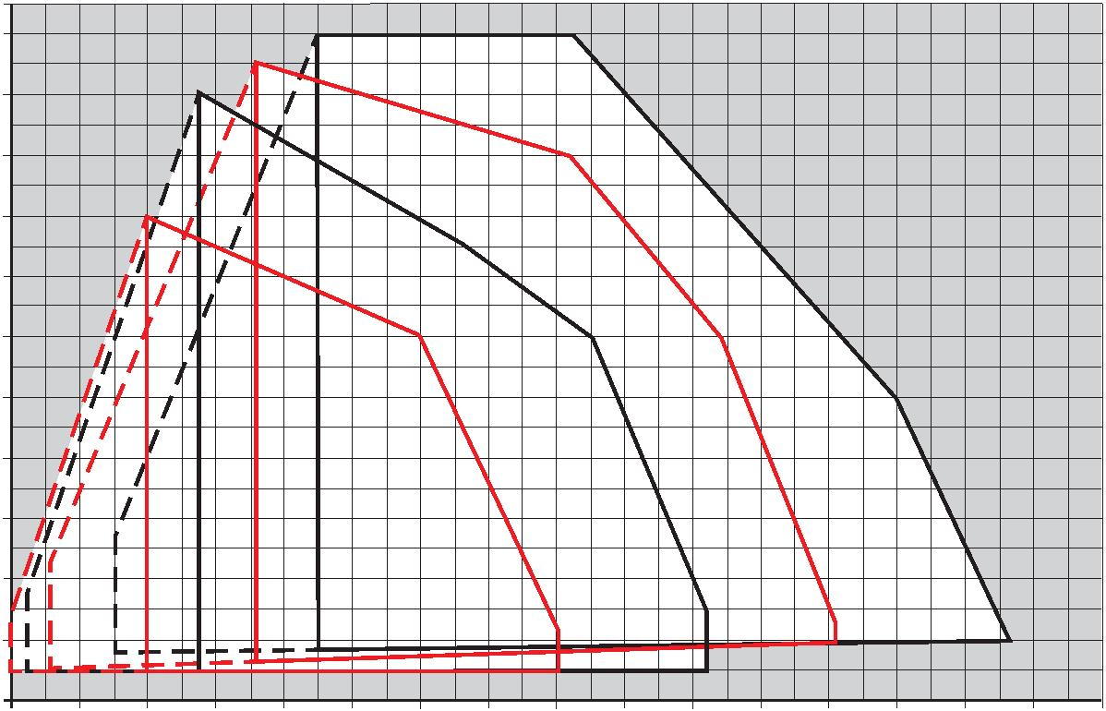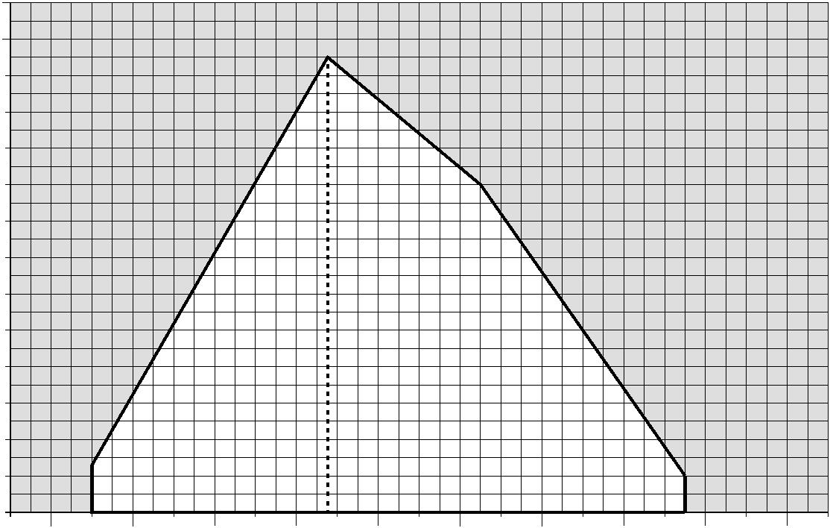Firing Rates
 | ꢄꢁ  ꢃꢂ |  | Rꢉ ꢅꢃꢁꢊꢋ FGR |  | Useful working field  for choosing the  burner
ꢃꢅ
Rꢉ ꢇꢃꢁꢊꢋ FGR
Modulation range
 | ꢃꢀ  ꢃꢄ  ꢃꢁ  ꢂ |  | Rꢉ ꢀꢃꢁꢊꢋ FGR |  | Test conditions  conforming to  EN676  Temperature: 20°C  Pressure: 1013,5  mbar  Altitude: 0 m a.s.l.
ꢅ
ꢀ
ꢄ
Rꢉ ꢆꢃꢁꢊꢋ FGR
ꢁ
 | ꢈꢄ  ꢀꢁꢁ ꢂꢁꢁ ꢃꢄꢁꢁ ꢃꢅꢁꢁ ꢄꢁꢁꢁ ꢄꢀꢁꢁ ꢄꢂꢁꢁ ꢆꢄꢁꢁ ꢆꢅꢁꢁ ꢀꢁꢁꢁ ꢀꢀꢁꢁ ꢀꢂꢁꢁ ꢇꢄꢁꢁ ꢇꢅꢁꢁ ꢅꢁꢁꢁ ꢅꢀꢁꢁ ꢅꢂꢁꢁ |  | kW
ꢃꢆ
ꢃꢌ
ꢃꢀ
ꢃꢃ
ꢃꢁ
ꢂꢄ
ꢂꢆ
Rꢎ ꢄꢁꢁꢏꢐ FGR
ꢂꢀ
ꢂꢃ
ꢂꢁ
ꢄ
ꢆ
ꢀ
ꢃ
 | ꢁ  ꢀꢁꢁ ꢂꢃꢁꢁ ꢃꢁꢁꢁ ꢃꢄꢁꢁ ꢅꢆꢁꢁ ꢀꢀꢁꢁ |  | ꢌꢃꢁꢁ ꢆꢁꢁꢁ ꢆꢄꢁꢁ ꢍꢆꢁꢁ ꢄꢀꢁꢁ kW
5
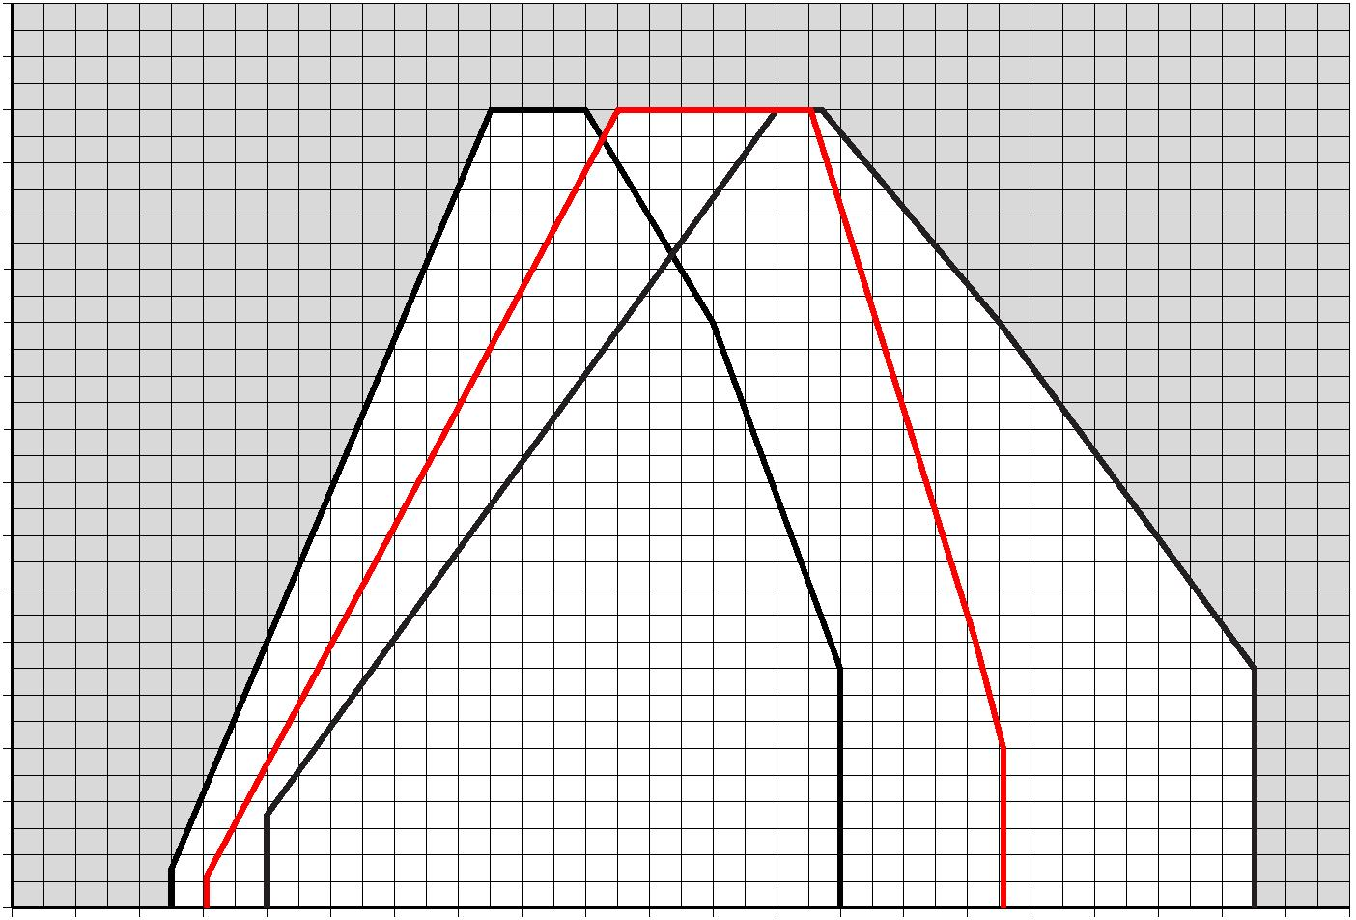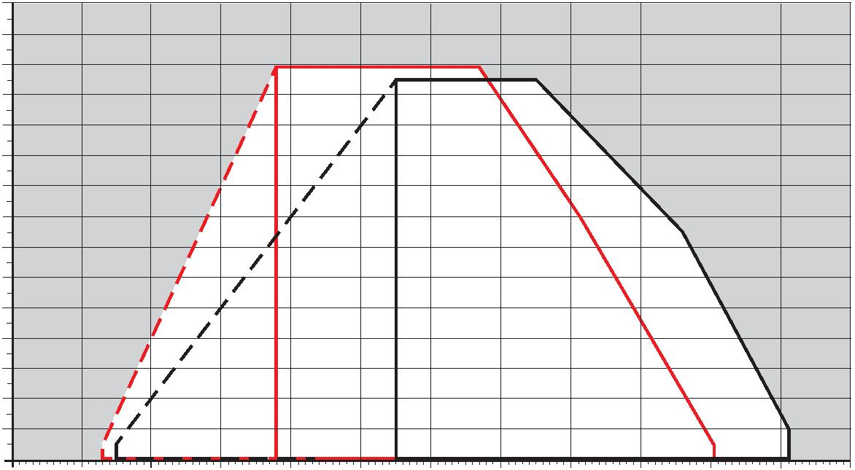Monoblock and Dual Block Gas FGR Burners
Firing Rates
 | 30  28  26 |  | Rꢀ ꢁꢂꢂꢂꢃꢄ FGR |  |  |  |  | Useful working field  for choosing the  burner
 | 24  22 |  |  |  | Rꢀ ꢁꢅꢂꢂꢃꢄ FGR
Modulation range
 | 20  18  16  14  12  10 |  | Test conditions  conforming to  EN676  Temperature: 20°C  Pressure: 1013,5  mbar  Altitude: 0 m a.s.l.
8
6
4
2
0
0 1000 2000 3000 4000 5000 6000 7000 8000 9000 10000 11000 12000
kꢋ
ꢆꢂ
 | ꢆꢁ  ꢆꢀ |  | Rꢇ ꢅꢃꢀꢀꢈꢉ FGR
ꢁꢄ
ꢁꢃ
Rꢇ ꢅꢆꢀꢀꢈꢉ FGR
ꢁꢂ
Rꢇ ꢁꢀꢀꢀꢈꢉ FGR
ꢁꢁ
ꢁꢀ
ꢅꢄ
ꢅꢃ
ꢅꢂ
ꢅꢁ
ꢅꢀ
ꢄ
ꢃ
ꢂ
ꢁ
ꢀ
ꢀ 1000 2000 3000 4000 5000 6000 7000 8000 9000 1000011000120001300014000150001600017000 1800019000 20000 21000 kꢏ
6
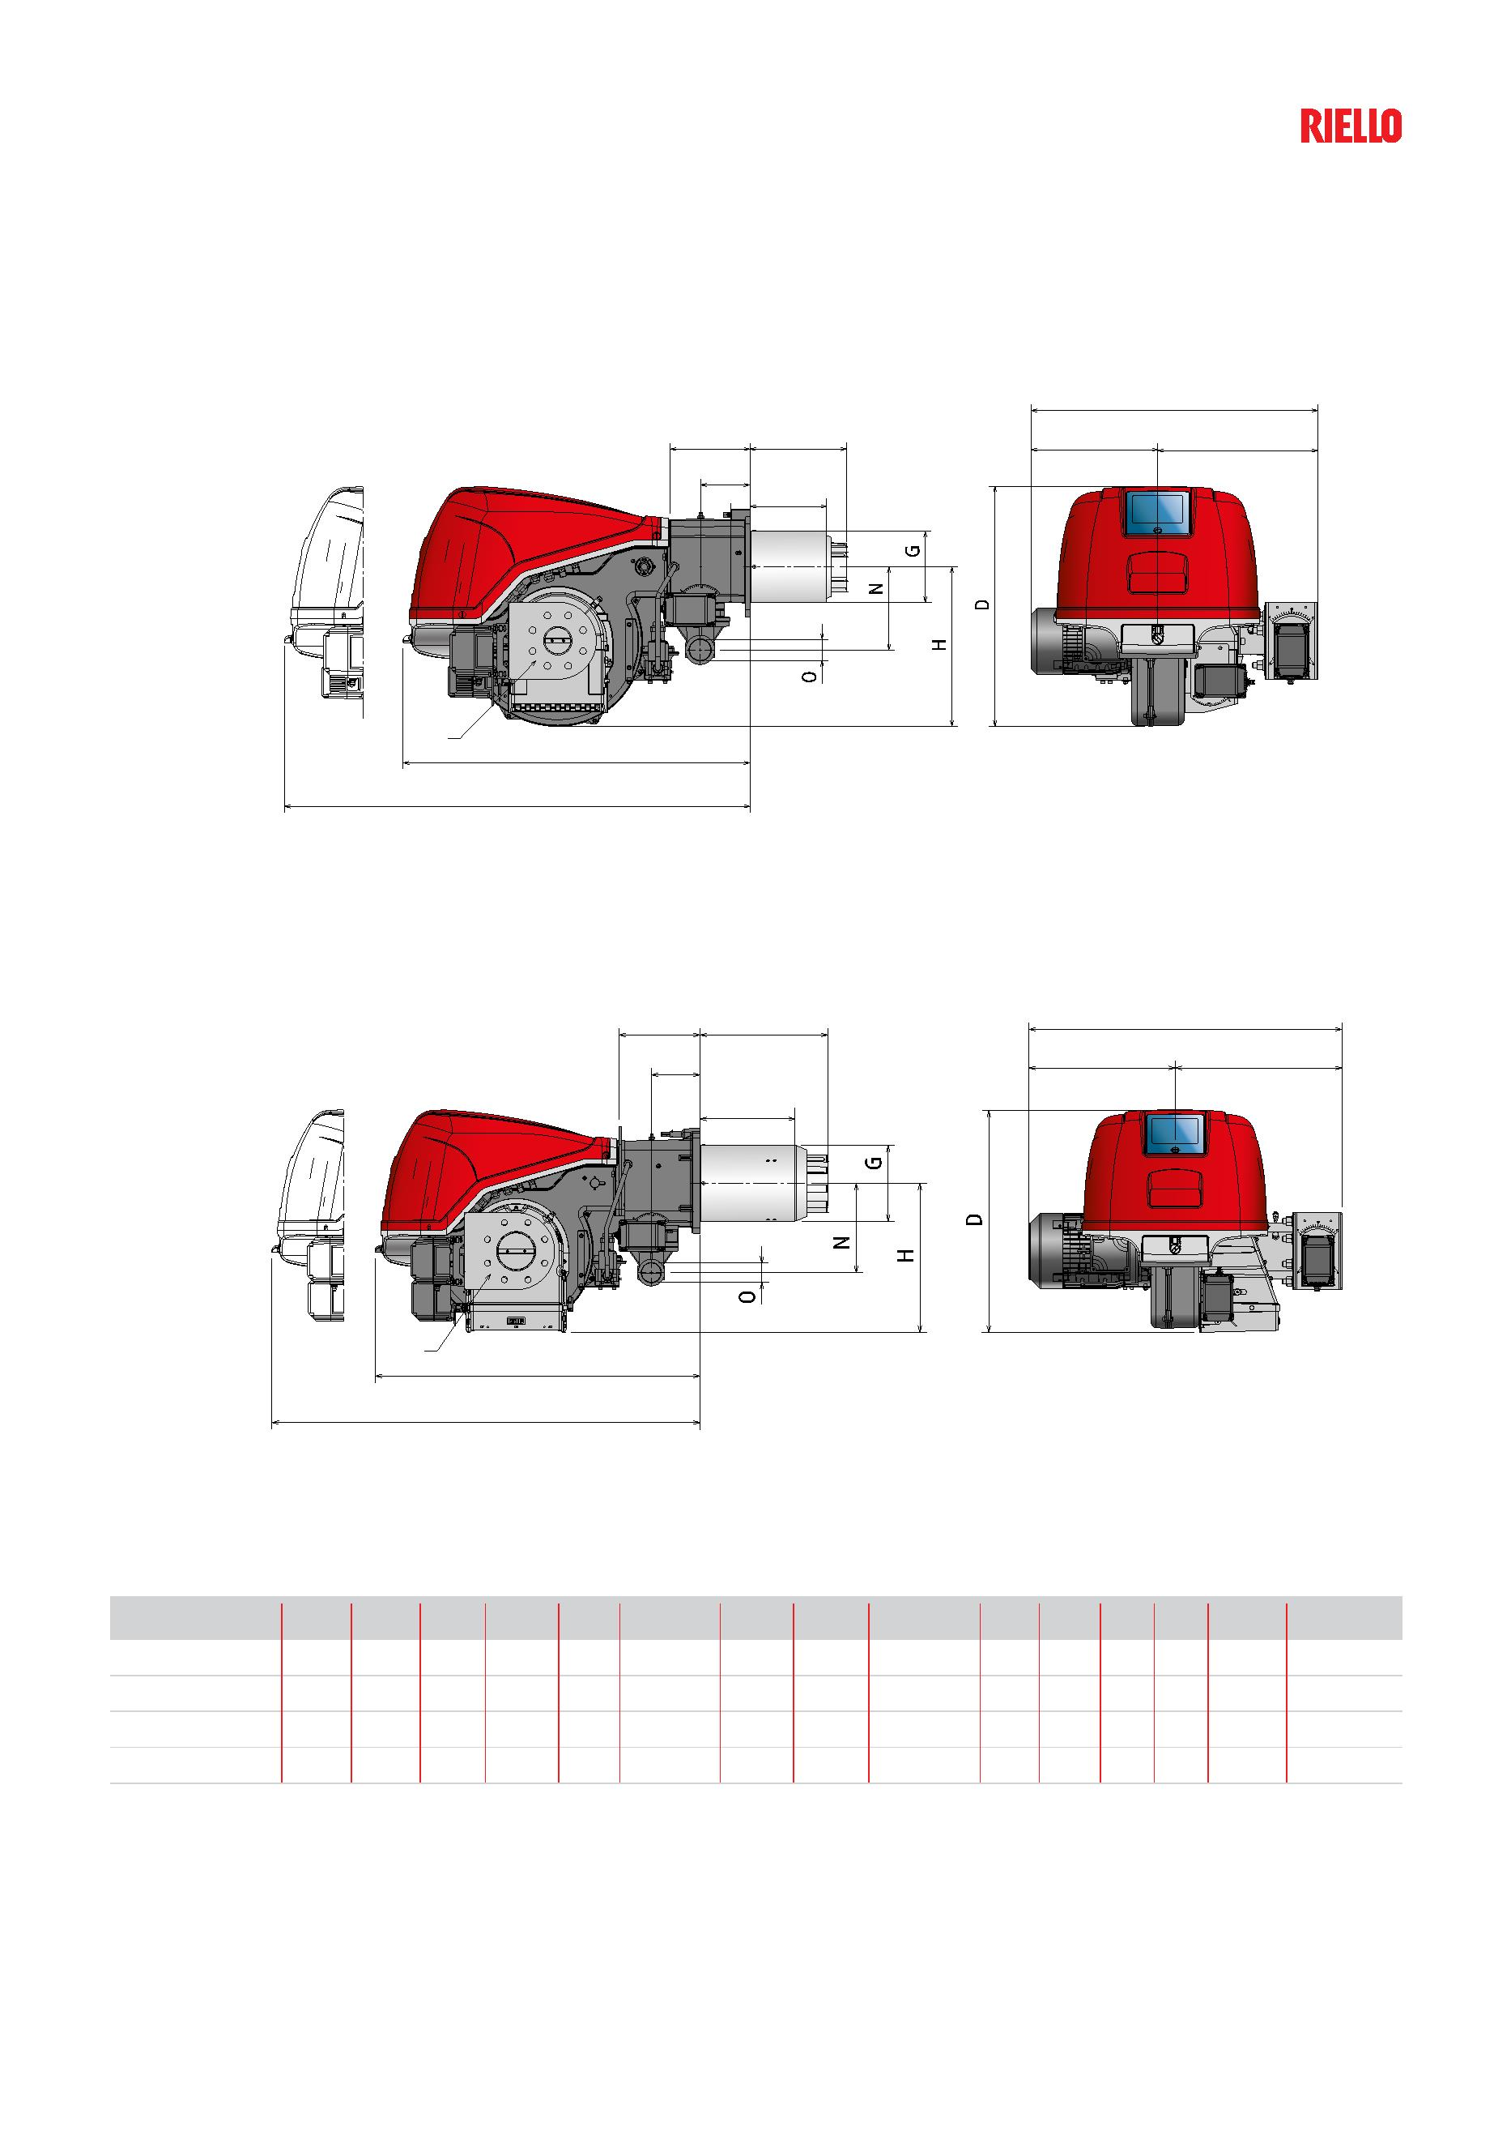Overall dimensions (mm)
Burner
RS 68-120/E FGR
ꢈ
ꢁ F B ꢇ
M
ꢉ
ꢀ
ꢄ
ꢂ
RS 160-200/E FGR
ꢈ ꢂ F
B ꢇ
M
ꢉ
ꢆ
ꢃ
ꢄ
MODEL A B C D E F-F (1) G H I L M N O S U-U (1)
u RS 68/E FGR 738 312 426 640 922 255-390 189 425 200-335 214 134 221 2” DN65 1393-1528
u RS 120/E FGR 763 337 426 640 922 255-390 189 425 200-335 214 134 221 2” DN65 1393-1528
u RS 160/E FGR 764 378 486 650 950 373-503 222 435 272-402 237 141 260 2” DN80 1520-1665
u RS 200/E FGR 913 427 486 650 950 373-503 222 435 272-402 237 141 260 2” DN100 1520-1665
(1) Dimension with extended head
7
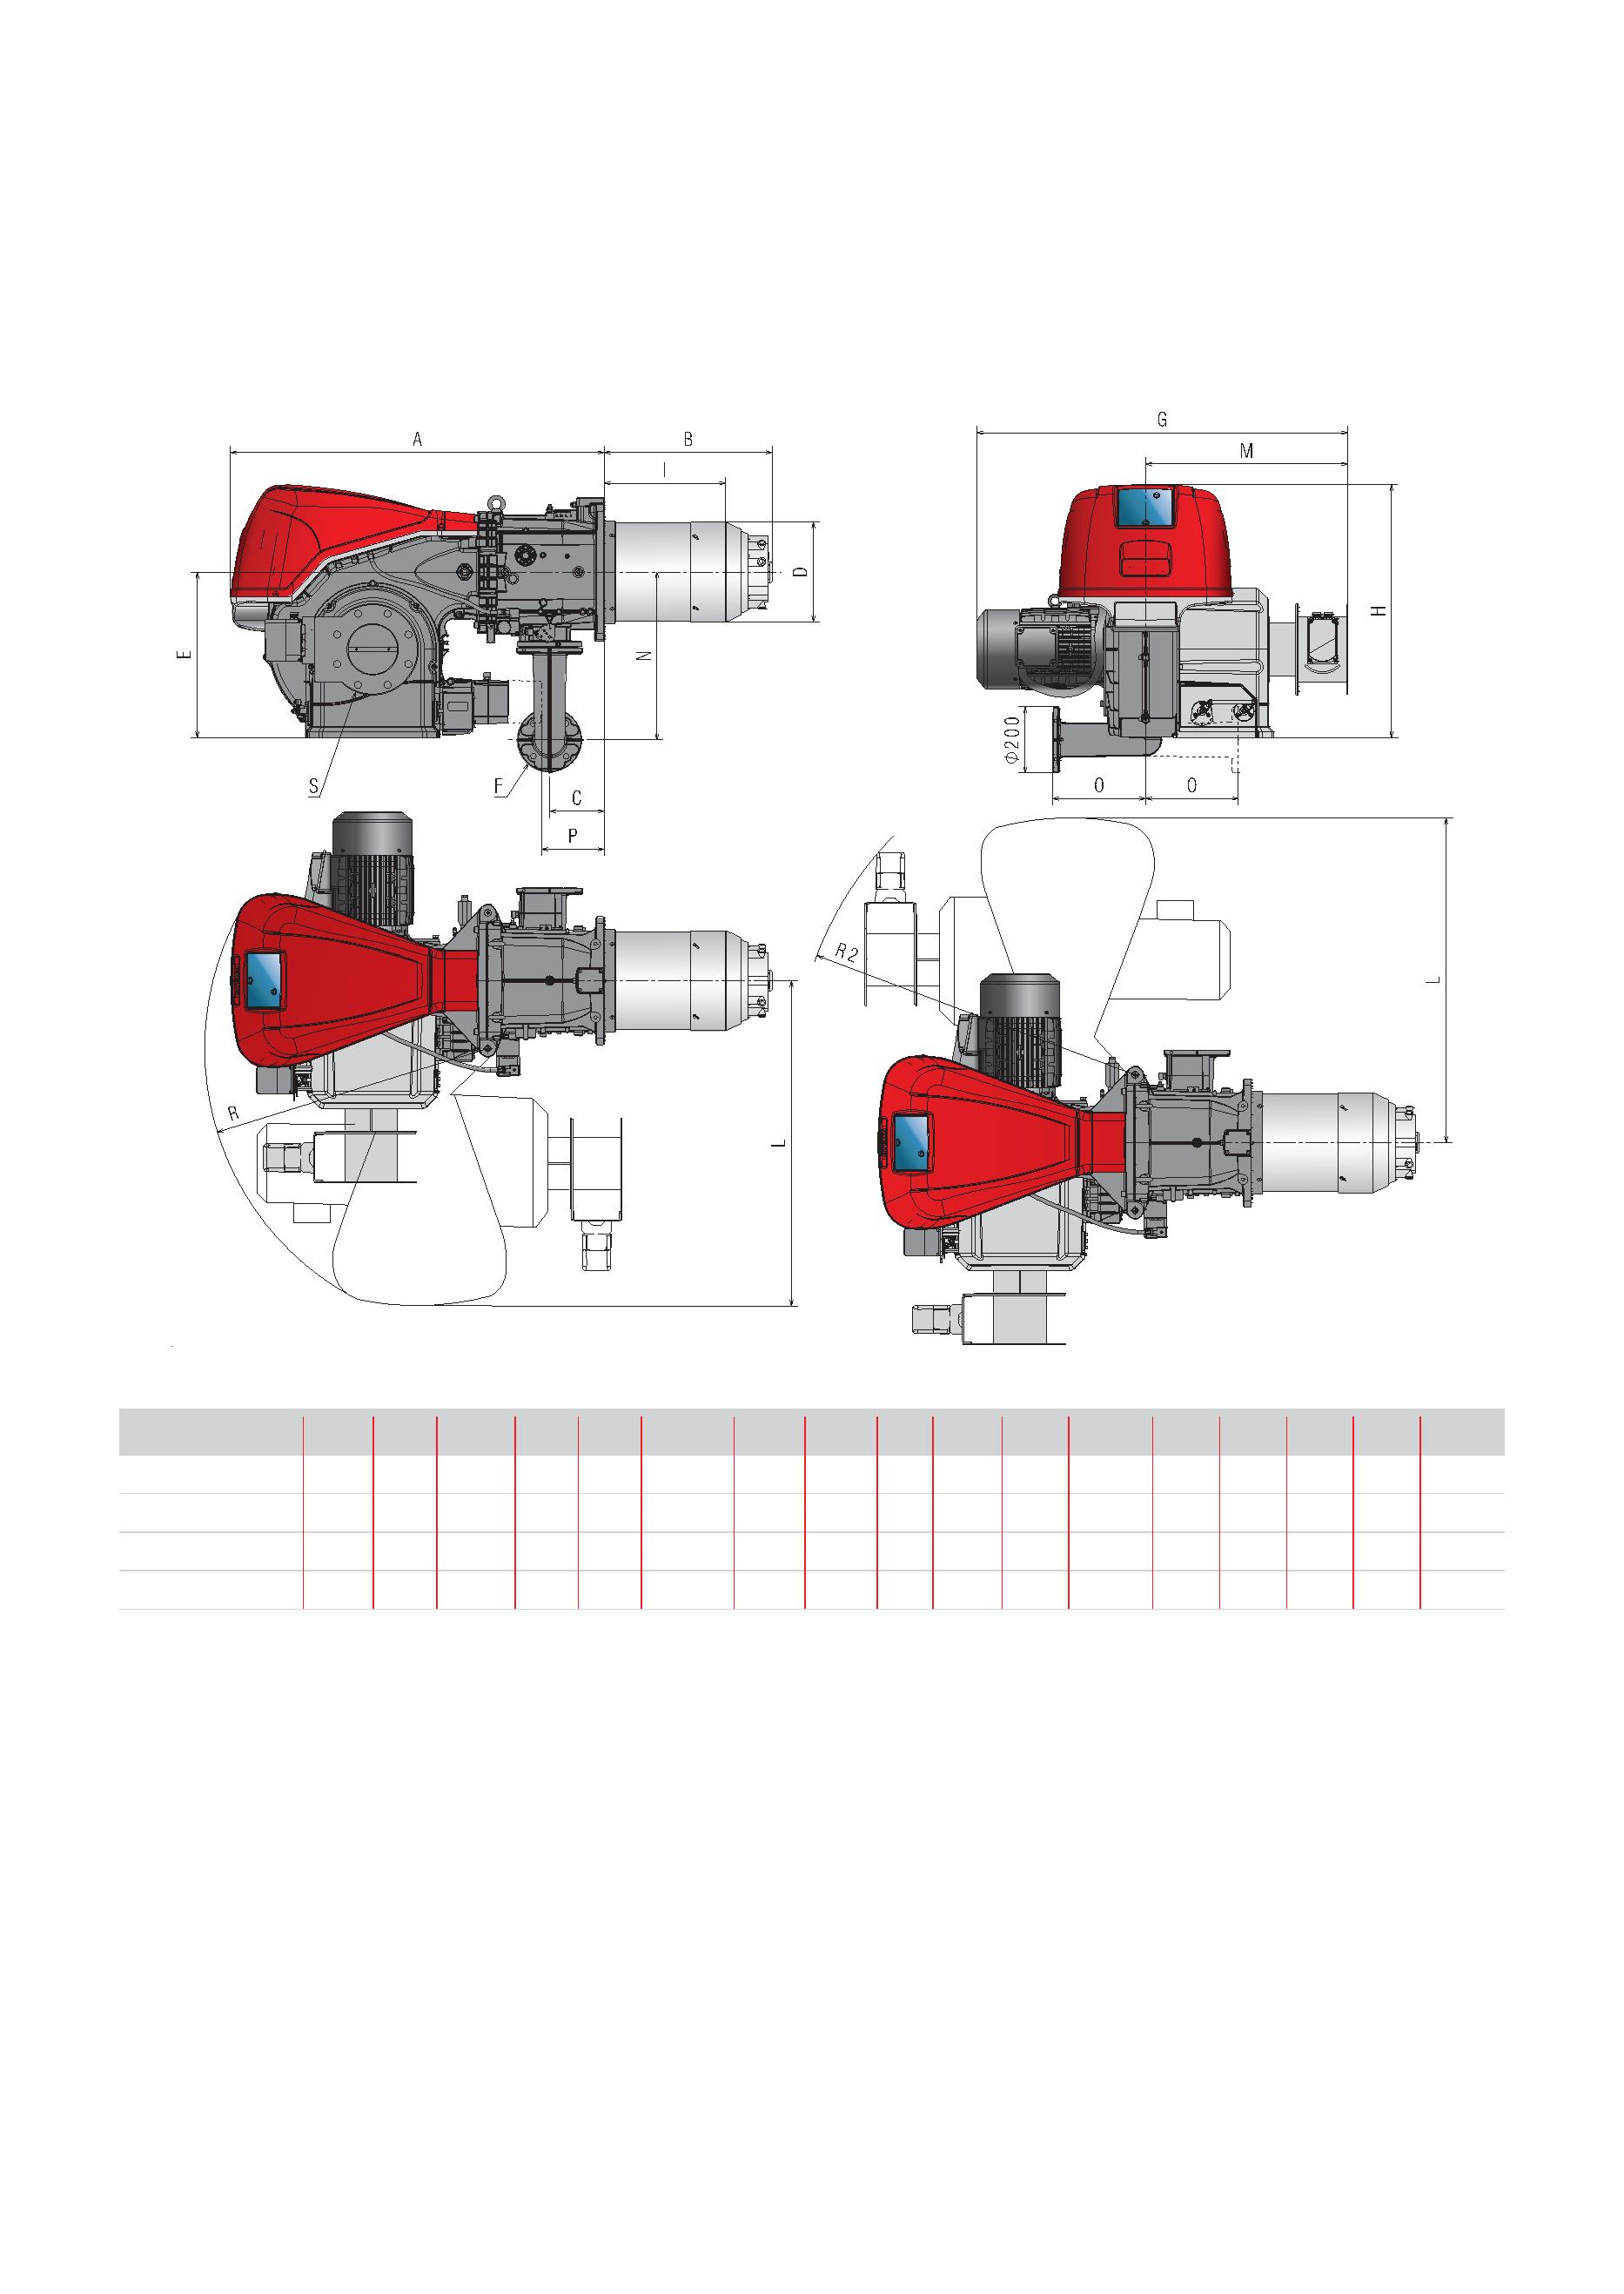Monoblock and Dual Block Gas FGR Burners
Overall dimensions (mm)
Burner
RS 310-610/E FGR
MODEL A B C D E F* G H I L M N O P** R R2 S
u RS 310/E FGR 1178 465 178 306 520 DN65 1185 790 346 1015 615 528 290 177 900 1045 DN100
u RS 410/E FGR 1178 517 178 313 520 DN65 1140 790 340 1015 615 528 290 177 890 1045 DN125
u RS 510/E FGR 1260 517 178 313 520 DN65 1140 790 360 1015 620 528 290 177 890 1045 DN125
u RS 610/E FGR 1260 517 178 336 520 DN65 1215 790 365 1015 632 528 290 177 10 1070 DN150
* The gas adaptor is set also for DN 80 bore.
** Maximum position for the extraction of the servomotor cover.
8
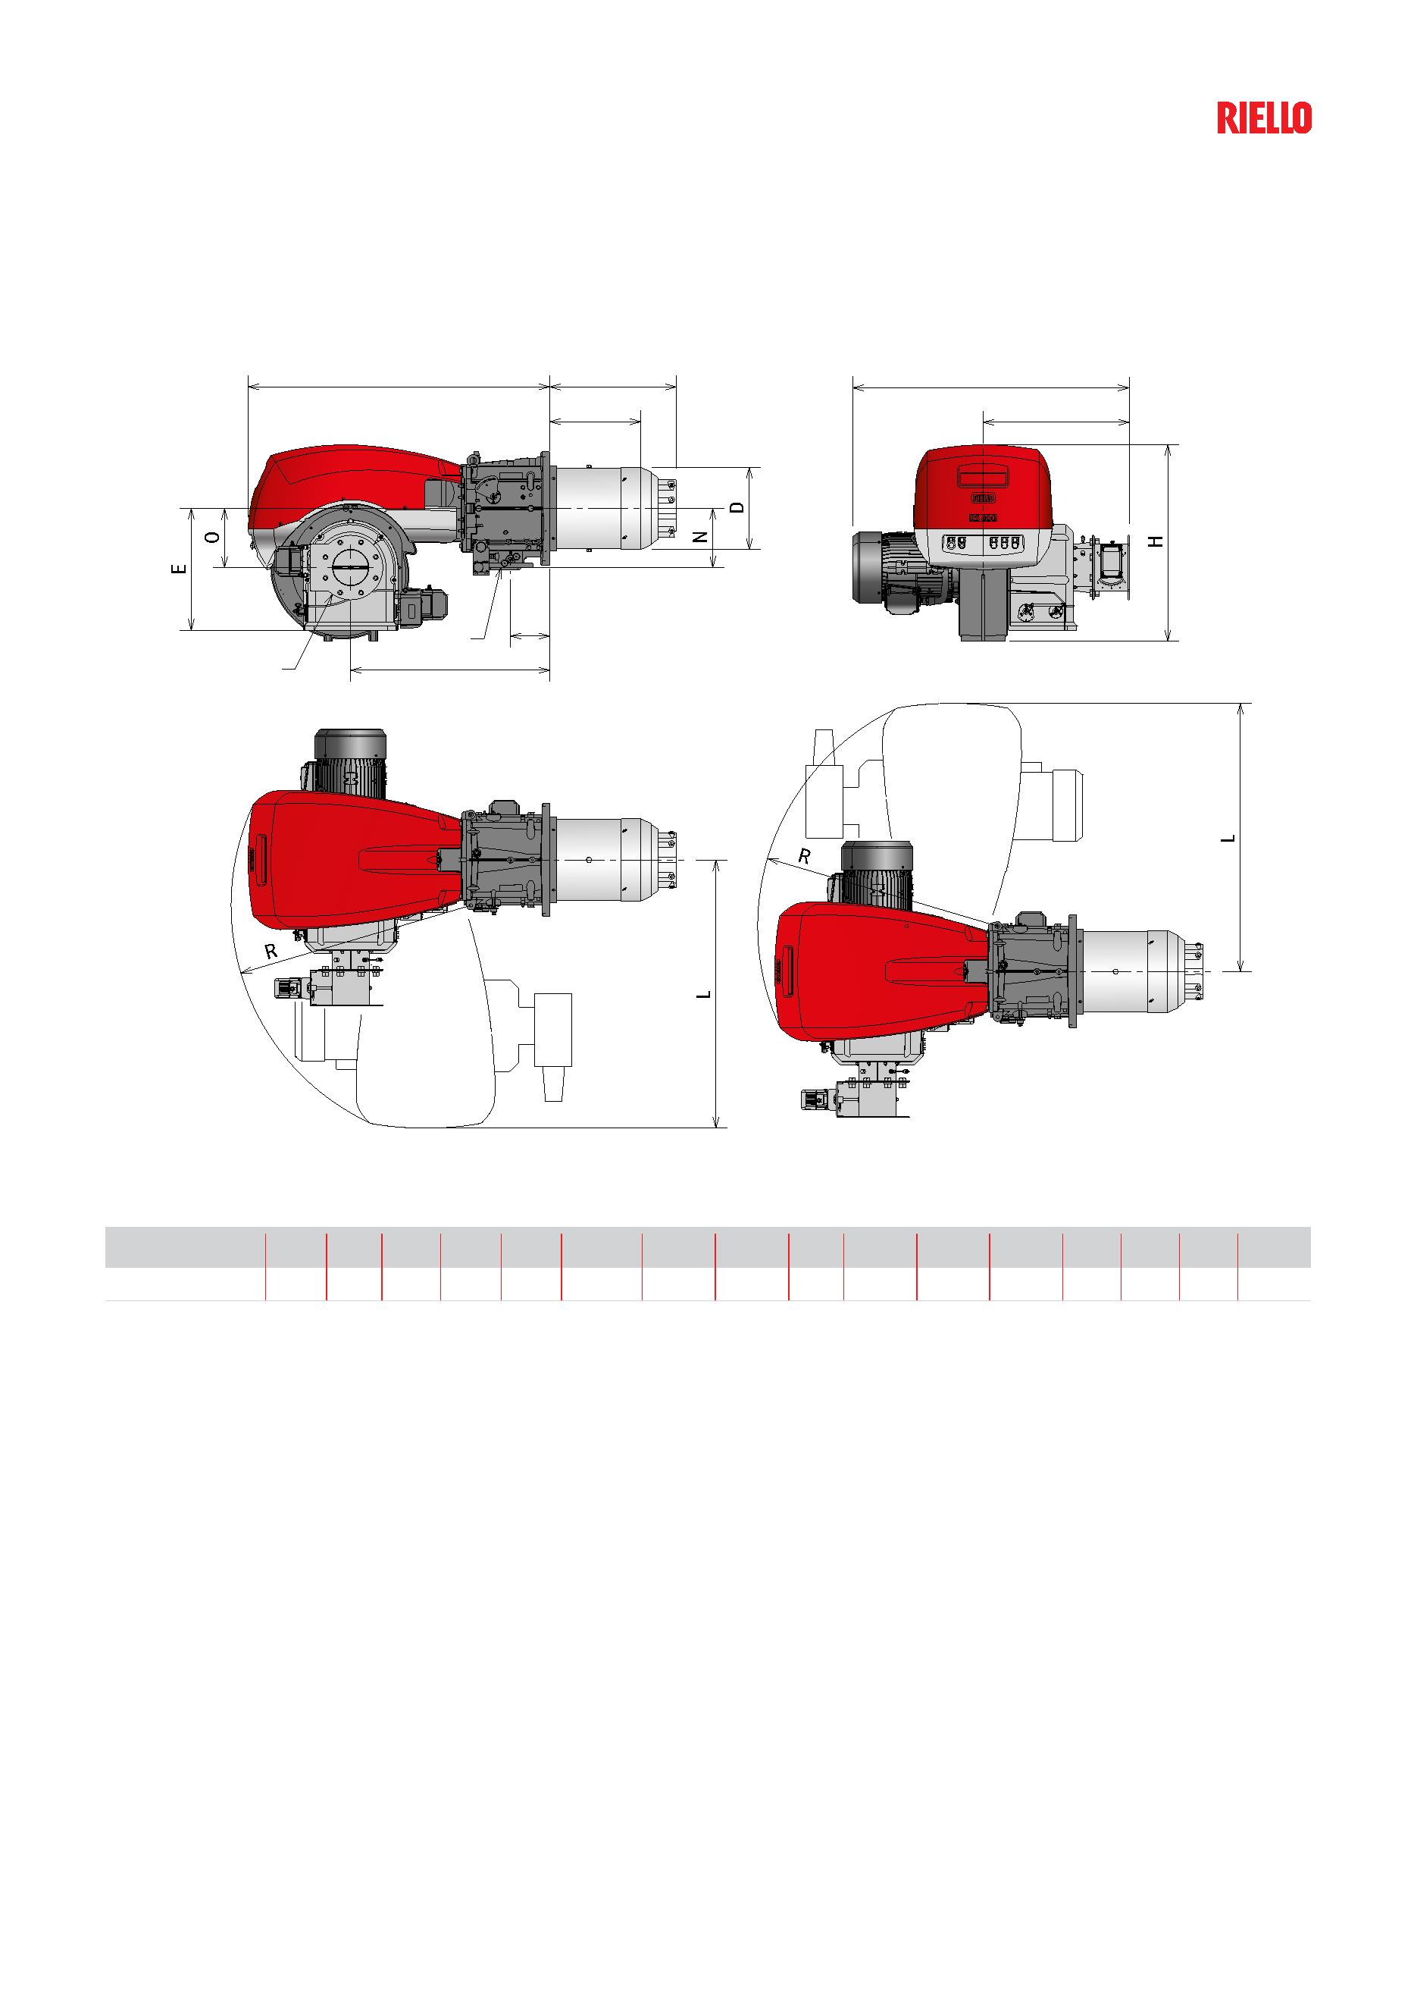Overall dimensions (mm)
Burner
RS 800/E FGR
ꢀ B G
ꢆ M
ꢇ
F
ꢃ ꢄ
MODEL A B C D E F* G H I L M N O P R S
u RS 800/E FGR 1332 560 173 363 538 DN80 1222 865 403 1175 645 260 261 880 1055 DN150
9
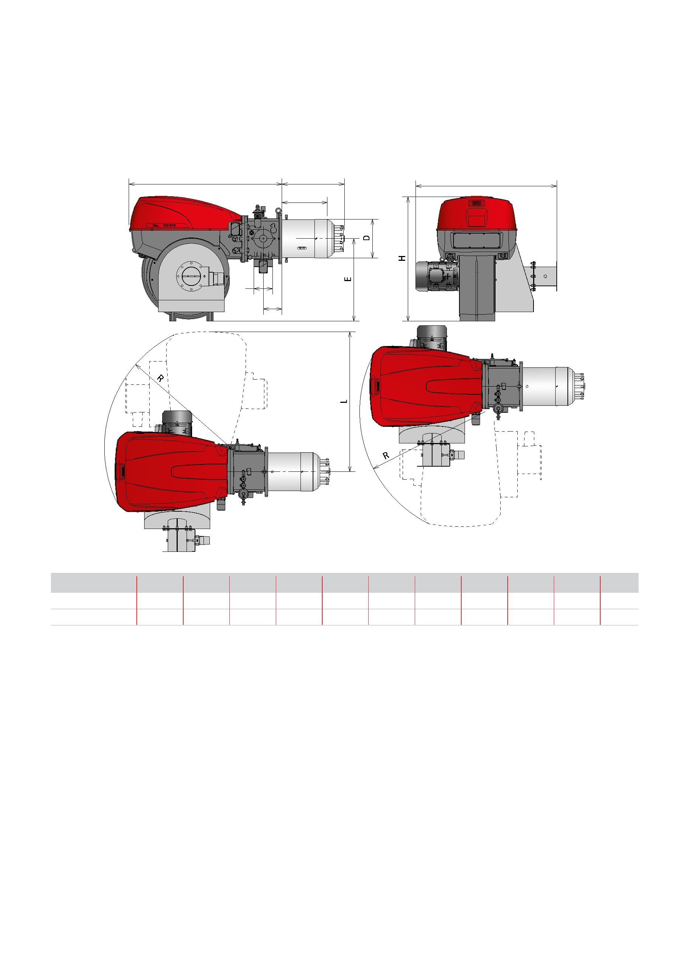Monoblock and Dual Block Gas FGR Burners
Overall dimensions (mm)
Burner
RS 1000-1200/E FGR
ꢁ B
G
ꢀ
F
ꢃ
MODEL A B C D E F G H I L R
u RS 1000/E FGR 1637 669 200 413 885 DN80 1510 1338 485 1493 1350
u RS 1200/E FGR 1637 670 200 456 885 DN80 1630 1338 463 1493 1350
10
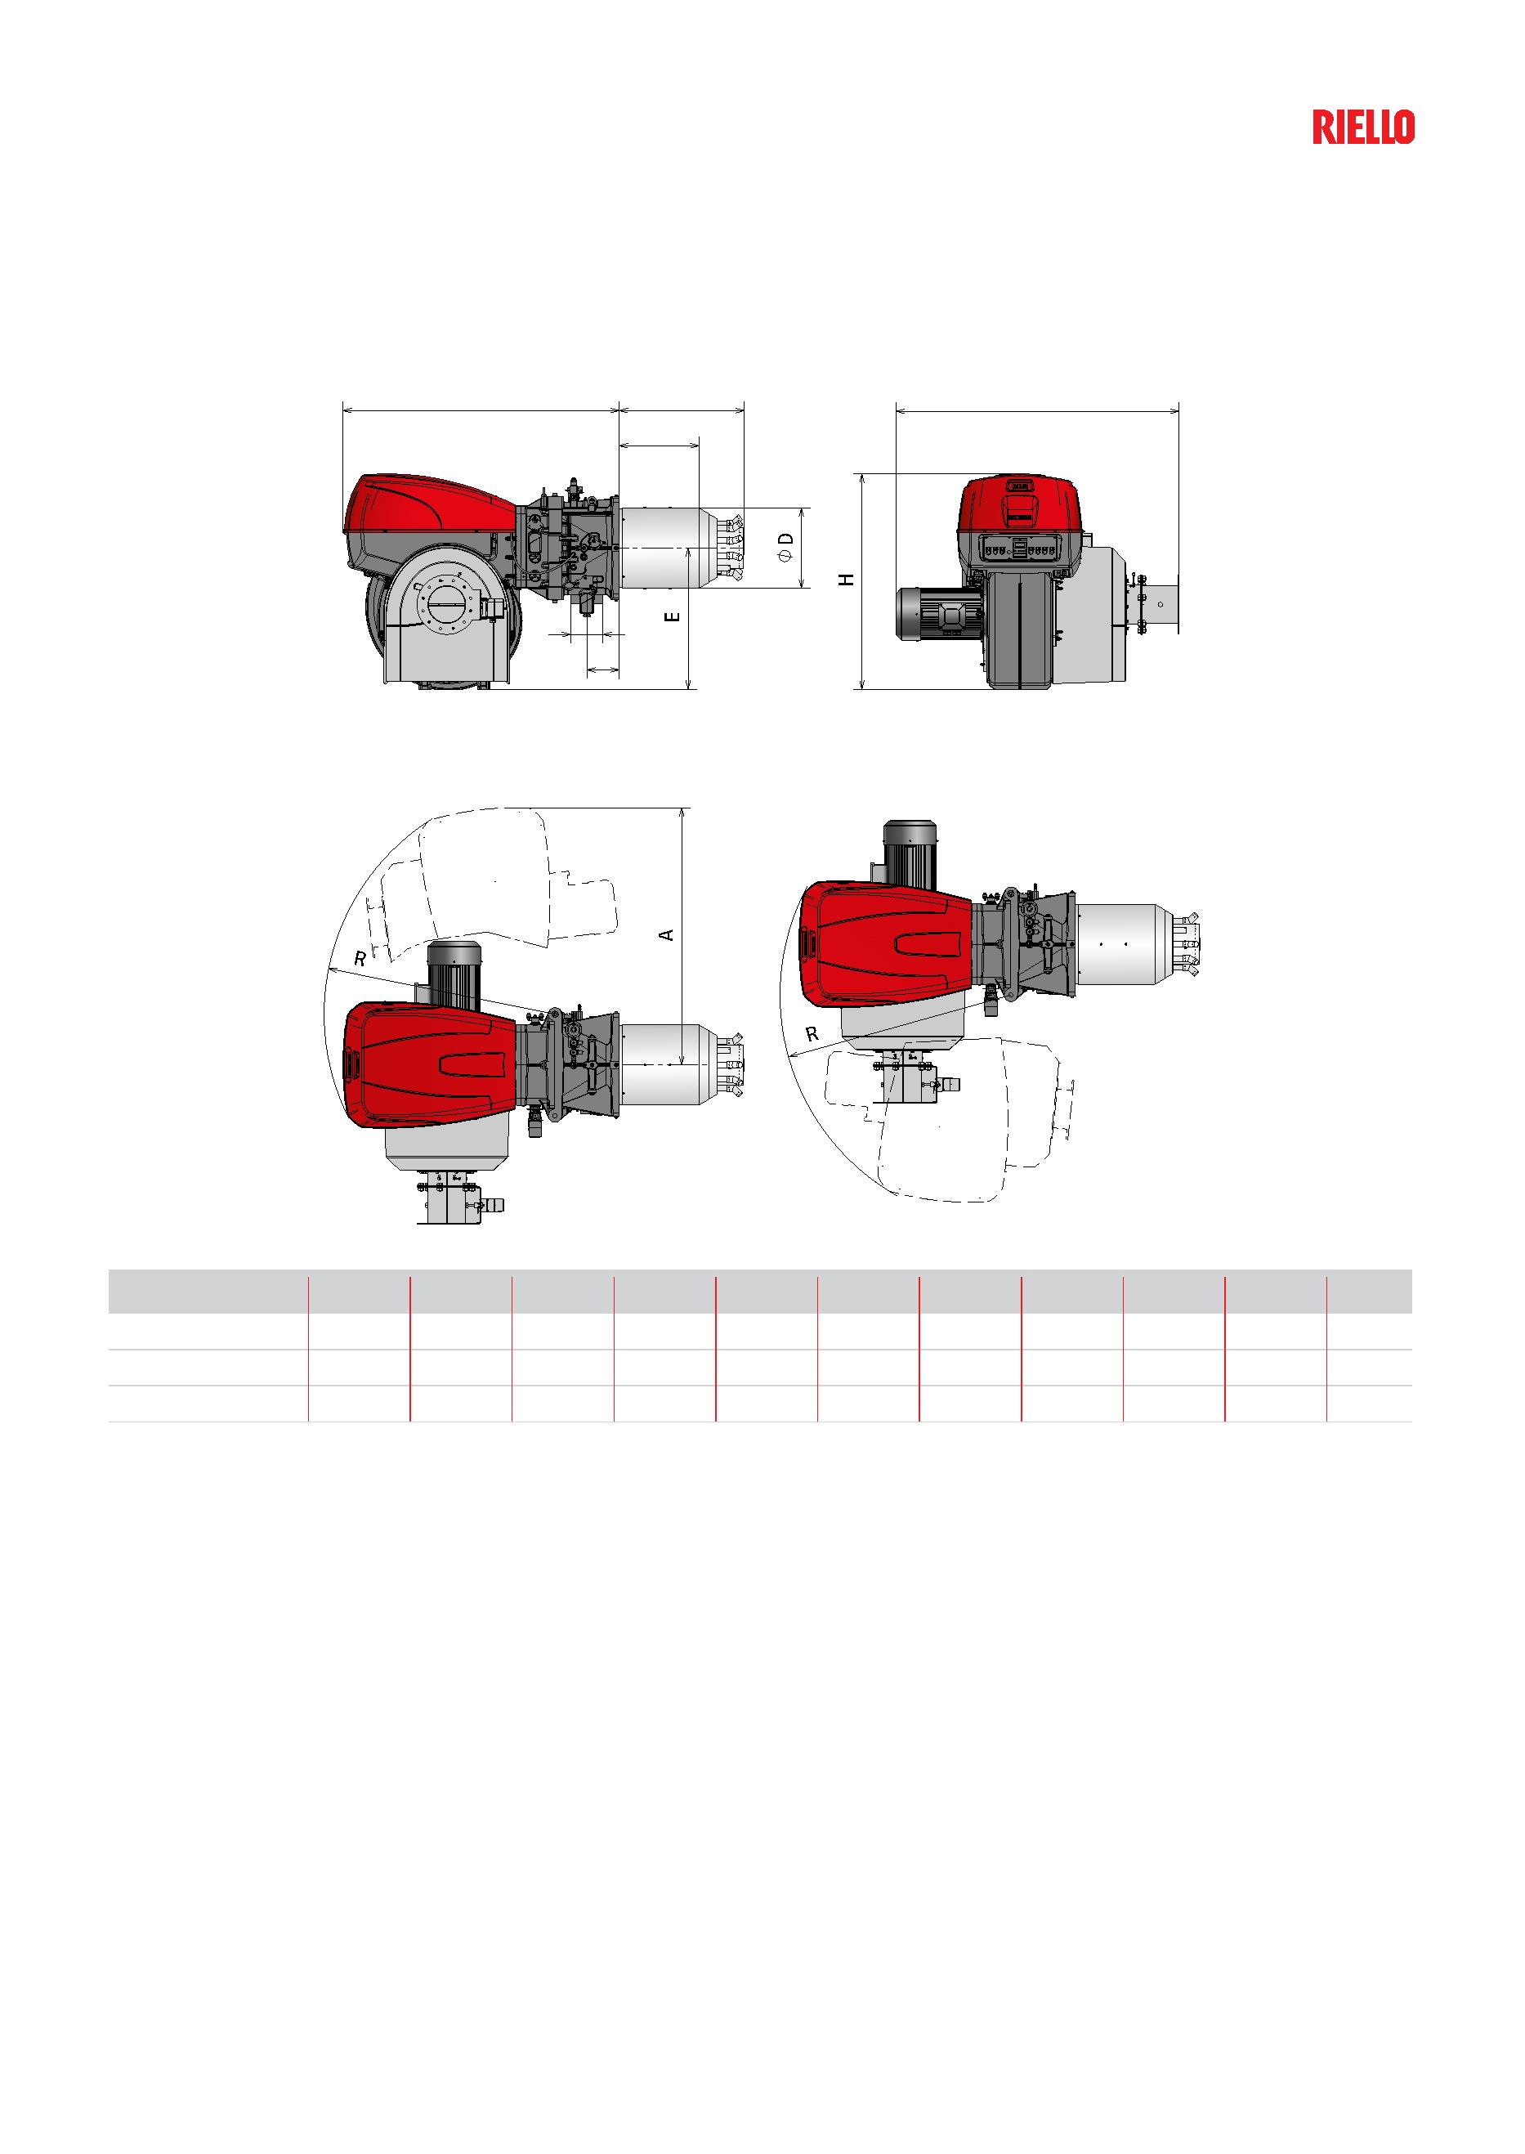Overall dimensions (mm)
Burner
RS 1300-1600-2000/E FGR
ꢀ ꢂ ꢅ
ꢃ
F
ꢄ
MODEL A C D E F H I L P R T
u RS 1300/E FGR 1782 220 544 960 DN80 1463 383 1928 1880 1565 613
u RS 1600/E FGR 1785 220 544 960 DN100 1463 544 1922 1880 1565 852
u RS 2000/E FGR 1782 220 590 960 DN100 1463 562 1922 1880 1565 852
11
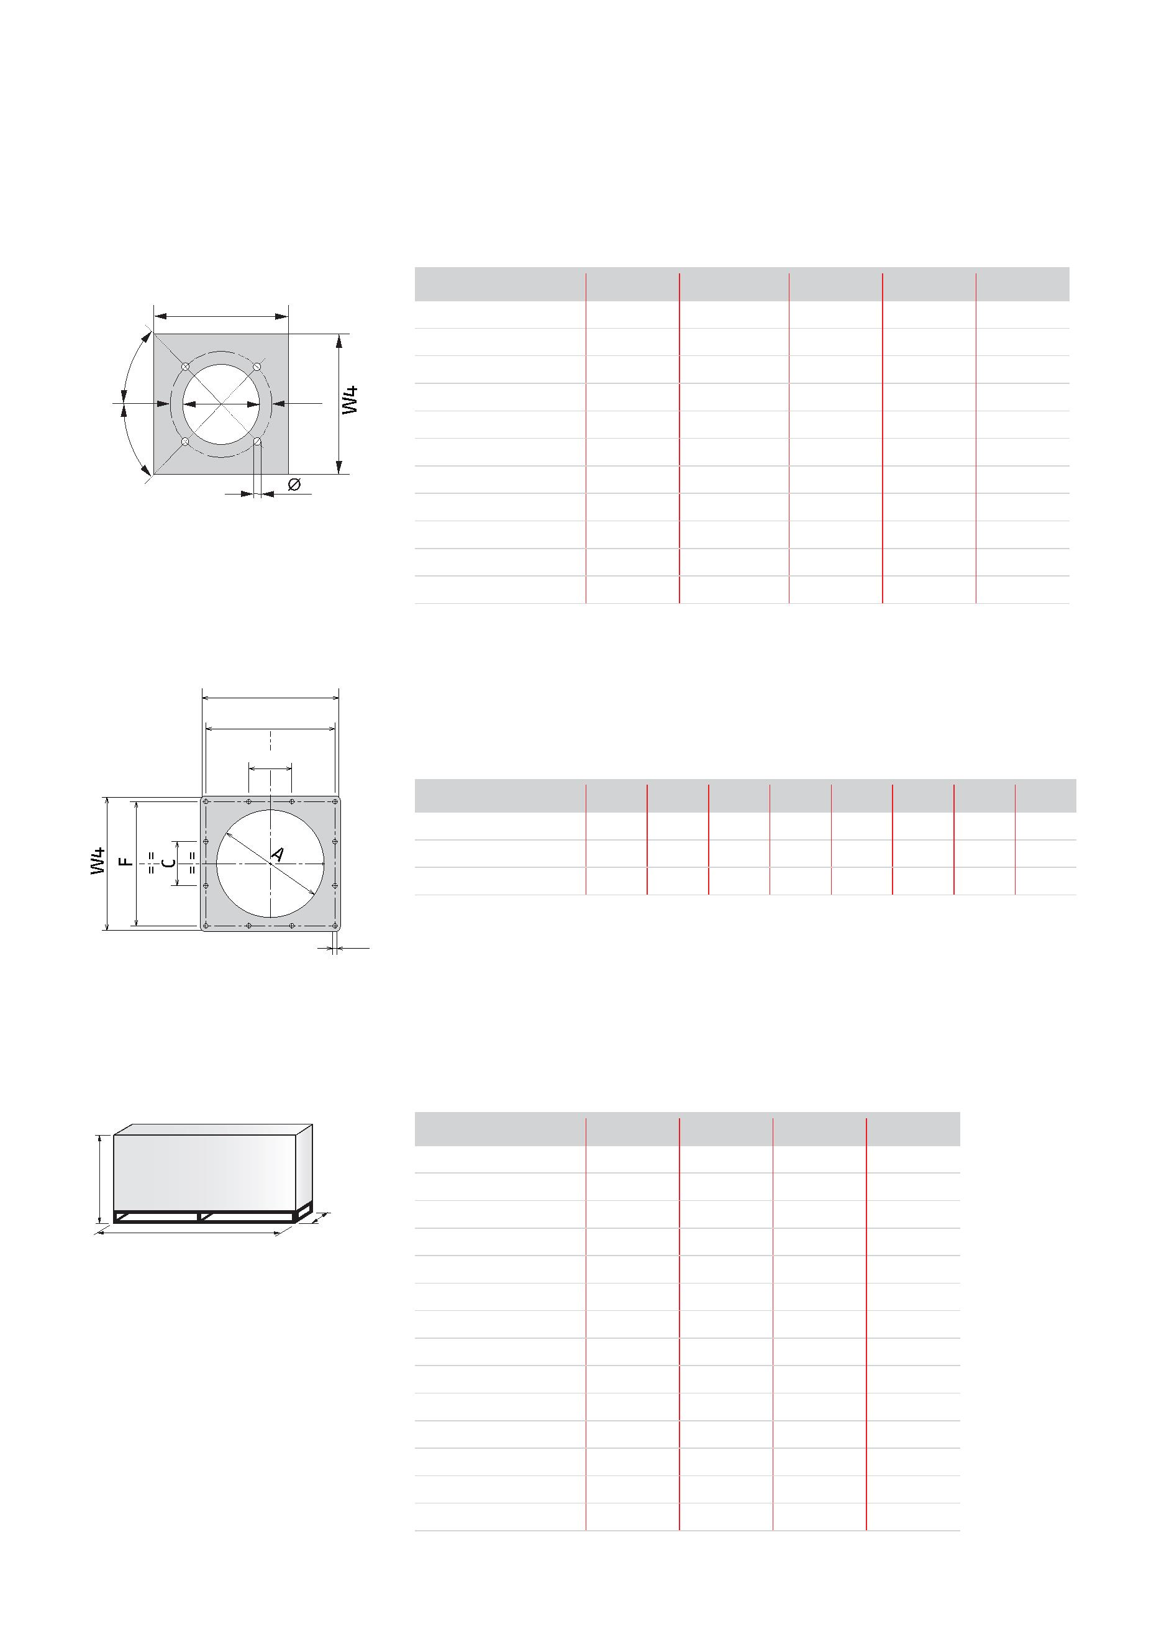Monoblock and Dual Block Gas FGR Burners
Overall dimensions (mm)
Burner - Boiler Mounting Flange
MODEL A B C W3 W4 ꢄꢅ
u RS 68/E FGR 195 275 - 325 M12 265 265
 |  | ꢁꢂꢃ |  | ꢀ |  | B |  | u RS 120/E FGR 195 275 - 325 M12 265 265  u RS 160/E FGR 230 325 - 368 M16 320 320  u RS 200/E FGR 230 325 - 368 M16 320 320
 | ꢁꢂꢃ |  |  |  |  |  |  | u RS 310/E FGR 335 452 M18 400 431  u RS 410/E FGR 335 452 M18 400 431  u RS 510/E FGR 335 452 M18 400 431  u RS 610/E FGR 350 452 M18 400 431
u RS 800/E FGR 400 495 M18 530 530
u RS 1000/E FGR 460 608 M20 530 530
u RS 1200/E FGR 500 608 M20 530 530
ꢄꢅ
ꢂ
ꢁ ꢁ
B
ꢁ ꢁ
MODEL A B C D E F W3 W4
u RS 1300/E FGR 580 215 220 M20 645 620 700 700
u RS 1600/E FGR 580 215 220 M20 645 620 700 700
u RS 2000/E FGR 580 215 220 M20 645 620 700 700
D
Packaging
MODEL X Y Z kg
Z |  |  |  |  | u RS 68/E FGR 1500 850 1000 100  u RS 120/E FGR 1500 850 1000 105
 | X |  | Y |  | u RS 160/E FGR 1500 850 1000 110  u RS 200/E FGR 1500 850 1000 148
u RS 310/E FGR 2040 1280 1125 265
u RS 410/E FGR 2040 1280 1125 265
u RS 510/E FGR 2040 1280 1125 265
u RS 610/E FGR 2040 1280 1125 295
u RS 800/E FGR 2150 1070 1425 320
u RS 1000/E FGR 2640 1700 1750 450
u RS 1200/E FGR 2640 1700 1750 470
u RS 1300/E FGR 2960 1750 1800 1180
u RS 1600/E FGR 2960 1750 1800 1180
u RS 2000/E FGR 2960 1750 1800 1220
12
Specification
STATE OF SUPPLY
Monoblock forced draught, Ultra Low NOx gas burner with Flue Gas Recirculation (FGR) system, with modulating
operation, fully automatic, made up of:
- High performance fan with low sound emissions - Air suction circuit
- Air damper for air setting controlled by a high precision servomotor
- Air pressure switch
- Three-phase Fan starting motor
- Low emission combustion head, that can be set on the basis of required output, fitted with:
- stainless steel end cone, resistant to corrosion and high temperatures
- flame stability disk
- Automatic regulator for gas delivery, controlled by a high precision servomotor
- Burner Pilot Ignition system, with dedicated gas train, to assure a high ignition reliability
- Flue gas recirculation butterfly valve controlled by a high precision servomotor
- Flue gas recirculation temperature probe to prevent condensation in burner intake
- Maximum gas pressure switch, with pressure test point, to stop the burner in the case of excess pressure on
the fuel supply line
- Electronic Cam control
- for air/fuel setting
- for output modulation with incorporated PID control of temperature or pressure of the heat generator
- with indication of operating status and parameters, error messages and diagnosis of fault causes
- Operator panel with LCD Display Interface, for combustion system commissioning and monitoring
- Burner safety control included on Electronic Cam device
- UV sensor for flame detection
- Main electrical supply terminal board - Burner on/off switch
- Manual or automatic output increase/decrease switch
- Contacts motor and thermal relay with release button
- Motor internal thermal protection
- Clean contacts relay
- Burner failure led signal and lighted release button
- Guides for opening the burner and inspecting the combustion head (RS 68 ÷ 200/E FGR)
- Hinge for opening the burner and inspecting the combustion head (RS 310 ÷ 2000/E FGR)
- Lifting rings
Standard equipment: Thermal insulation screen
- Screws to fix the burner flange to the boiler
- Screws to fix the gas train flange
- Gasket for gas train flange
- Pressure switch for leak detection control of gas train
- Spare parts catalogue
- Instruction handbook for installation, use and maintenance
13
Monoblock and Dual Block Gas FGR Burners
Available models
Burners
 | CODE MODEL |  | HEAT OUTPUT  NATURAL GAS  (kW) (Nm³/h) |  | TOTAL  ELECTRICAL  POWER  (kW) |  | MOTOR  ELECTRICAL  POWER  (kW) |  | NOTE
20130750 RS 68/E FGR TC FS1 3/400/50 195/350-810 20/35 - 81 2,1 1,5 (1)(2)
20130751 RS 120/E FGR TC FS1 3/400/50 300/595 - 1150 30/60 - 115 2,9 2,2 (1)(2)
20130724 RS 160/E FGR TC FS1 3/400/50 350/958 - 1849 35/96 - 185 5,3 4,5 (1)(2)
20130748 RS 200/E FGR TC FS1 3/400/50 550/1372 - 2300 55/137 - 230 6,5 5,5 (1)(2)
20128711 RS 310/E FGR TC FS1 3/400/50 400/1200 - 3630 40/120 -363 9,1 7,5 (1)(2)
20128715 RS 410/E FGR TC FS1 3/400/50 500/1500 - 4450 50/150 - 445 10,6 9,2 (1)(2)
20128716 RS 510/E FGR TC FS1 3/400/50 680/1800 - 5250 68/180 - 525 13,9 12,0 (1)(3)
20128724 RS 610/E FGR TC FS1 3/400/50 1000/2200 - 6250 100/220 - 625 16,9 15,0 (1)(3)
20128145 RS 800/E FGR TC FS1 3/400/50 1200/3500 - 7000 120/350 - 700 24 22,0 (1)(3)
20129169 RS 1000/E FGR TC FS1 3/400/50 1100/4000 - 10100 110/400 - 1010 25,7 22,0 (1)(3)
20129173 RS 1200/E FGR TC FS1 3/400/50 1500/5500 - 11100 150/550 - 1110 28,7 25,0 (1)(3)
20130195 RS 1300/E FGR TC FS1 3/400/50 2500/7500 - 13000 250/750 - 1300 34,7 30,0 (1)(3)
20130194 RS 1600/E FGR TC FS1 3/400/50 3065/9503 - 15560 307/950 - 1556 41,5 37,0 (1)(3)
20130193 RS 2000/E FGR TC FS1 3/400/50 4000/12000 - 19500 400/1200 - 1950 49,3 45,0 (1)(3)
(1) Power range referred to a Low NOx performance conformingto the Class 3 of EN 676 European Standard,
with 0% of Flue Gas Recirculation; by increasing the recirculation % in order to achieve an ULTRA Low NOx
emission the burner’s maximum output will be reduced
(2) Direct starter fan motor
(3) Star delta fan motor starter
For more information about product codes, please contact Riello Burners Commercial and Technical
Department, our Application Engineers will be pleased to help you.
Burner accessories Extended head kit
 | BURNER STANDARD HEAD  LENGTH (mm) |  | EXTENDED HEAD  LENGTH (mm) |  | KIT CODE
u RS 160/E FGR 373 503 20131539
u RS 200/E FGR 373 503 20131510
Accessories for modulating operation
BURNER PROBE TYPE RANGE (°C) (bar) PROBE CODE
Temperature PT 100 -100 ÷ 500°C 3010110
 | uꢀAll models |  | Pressure 4 ÷ 20 mA 0 ÷ 2,5 bar 3010213  Pressure 4 ÷ 20 mA 0 ÷ 16 bar 3010214
Pressure 4 ÷ 20 mA 0 ÷ 25 bar 3090873
14
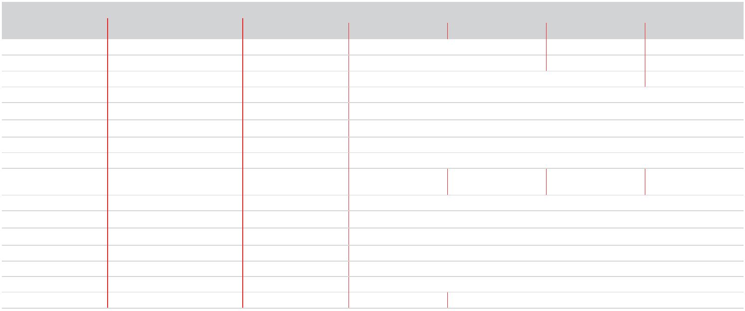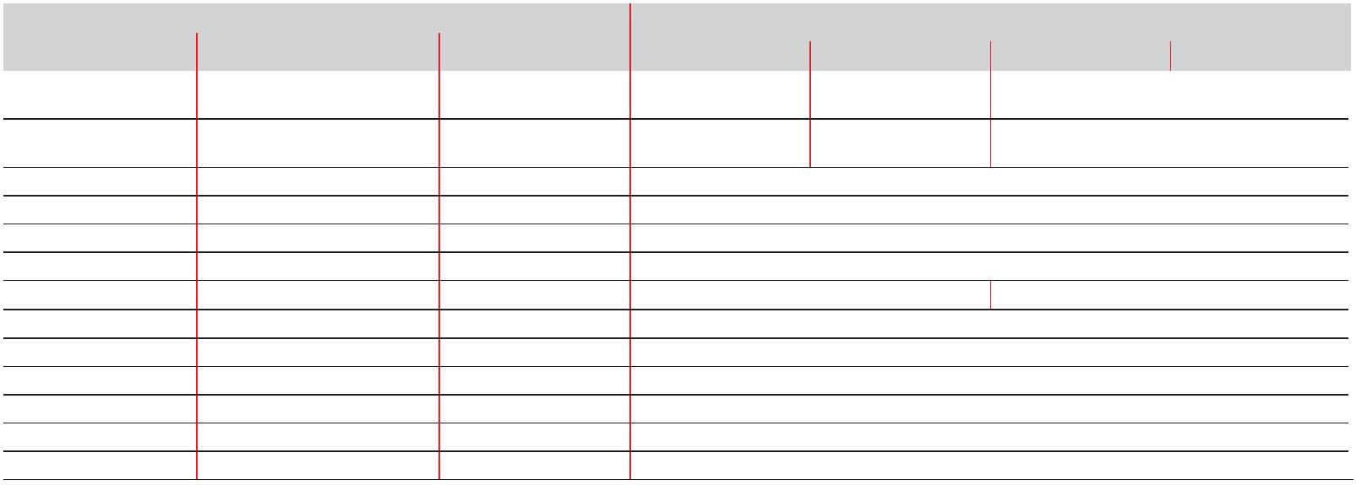Available models
Gas Trains
GAS TRAIN ADAPTER CODE
CODE MODEL Ø RS 68 RS 120 RS 160 RS 200
3970258* MB 410/1 - RT 52 Rp 1” ¼ 3010126 l l
3970600* MB 410/1 - RT 52 Rp ¾” 3000824 + 3000843 l l
3970256* MB 412/1 - RT 52 Rp 1” ½ 3000843 l
3970250* MB 415/1 - RT 52 Rp 1” ½ 3000843
3970257* MB 420/1 - RT 52 Rp 2” □
3970221* MBC 1200/1 - RSM 60 Rp 2” □
3970222* MBC 1900/1 - FSM 40 DN 65 3000825
3970223* MBC 3100/1 - FSM 40 DN 80 3000826
3970224* MBC 5000/1 - FSM 80 DN 100 l l l 3010370 +
3000826
3970145* CB 512/1 - RSM 30 Rp 1” ½ 3000843
3970146* CB 520/1 - RSM 30 Rp 2” □
20044659* CB 525/1 - RSM 30 Rp 2” □
3970147* CB 5065/1 - FSM 30 DN 65 3000825
3970148* CB 5080/1 - FSM 30 DN 80 3000826
3970149* CB 50100/1 - FSM 30 DN 100 3010370 + 3000826
20015871* CB 50125/1 - FSM 30 DN 125 l 3010224 + 3000826
Please see designation of Gas Train Series in the page before the Catalogue index.
* 230V/50Hz -220V/60Hz electrical supply.
The valves seal control device is compulsory (conforming to EN 676) on gas trains to burners with a maximum output over 1200 kW.
The seal control function is managed by REC control box, by installation on gas train of a pressure switch (please see Gas train accessories
paragraph); it is included as standard equipment on RS 120/E-EV-160/E-EV-200/E-EV BLU models.
To select the gas train please refer to the instruction manual. l Not available.
□ Additional adapter not necessary, the gas train may be connected directly to the burner.
GAS TRAIN ADAPTER CODE
CODE MODEL Ø RS 310 RS 410 RS 510 RS 610
3970250* MB 415/1 - RT 52 Rp 1” ½ 3000826 +
20064220 l l l
3970257* MB 420/1 - RT 52 Rp 2” 3000826 +
20042324 l l l
3970221* MBC 1200/1 - RSM 60 Rp 2” 3000826 + 20042324
3970222* MBC 1900/1 - FSM 40 DN 65 3010221
3970223* MBC 3100/1 - FSM 40 DN 80 3010222
3970224* MBC 5000/1 - FSM 80 DN 100 3010222 - 3010370
3970145* CB 512/1 - RSM 30 Rp 1” ½ 3000826 + 20064220 l l
3970146* CB 520/1 - RSM 30 Rp 2” 3000826 + 20042324 l
20044659* CB 525/1 - RSM 30 Rp 2” 3000826 + 20042324
3970147* CB 5065/1 - FSM 30 DN 65 3010221
3970148* CB 5080/1 - FSM 30 DN 80 3010222
3970149* CB 50100/1 - FSM 30 DN 100 3010223 - 3010370
20015871* CB 50125/1 - FSM 30 DN 125 3010224
Please see designation of Gas Train Series in the page before the Catalogue index.
* 230V/50Hz -220V/60Hz electrical supply. ** 230V/50Hz electrical supply.
The valves seal control device is compulsory (conforming to EN 676) on gas trains to burners with a maximum output over 1200 kW.
The seal control function is managed by REC control box, by installation on gas train of a pressure switch (please see Gas train accessories paragraph).
To select the gas train please refer to the instruction manual. l Not available.
□ Additional adapter not necessary, the gas train may be connected directly to the burner.
15
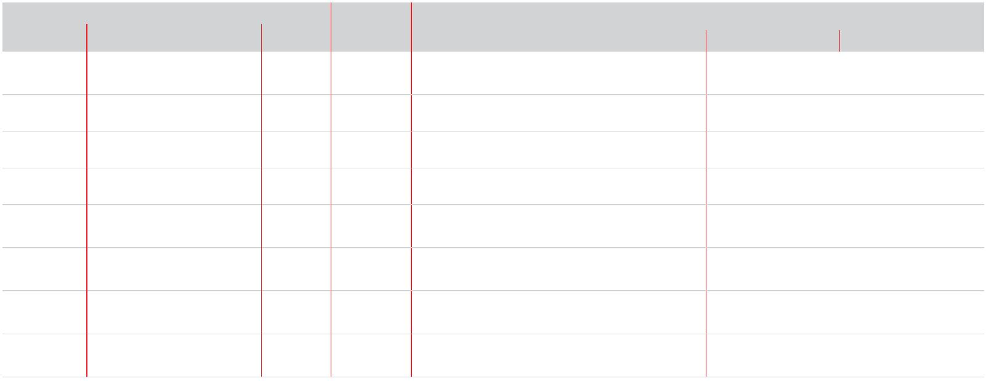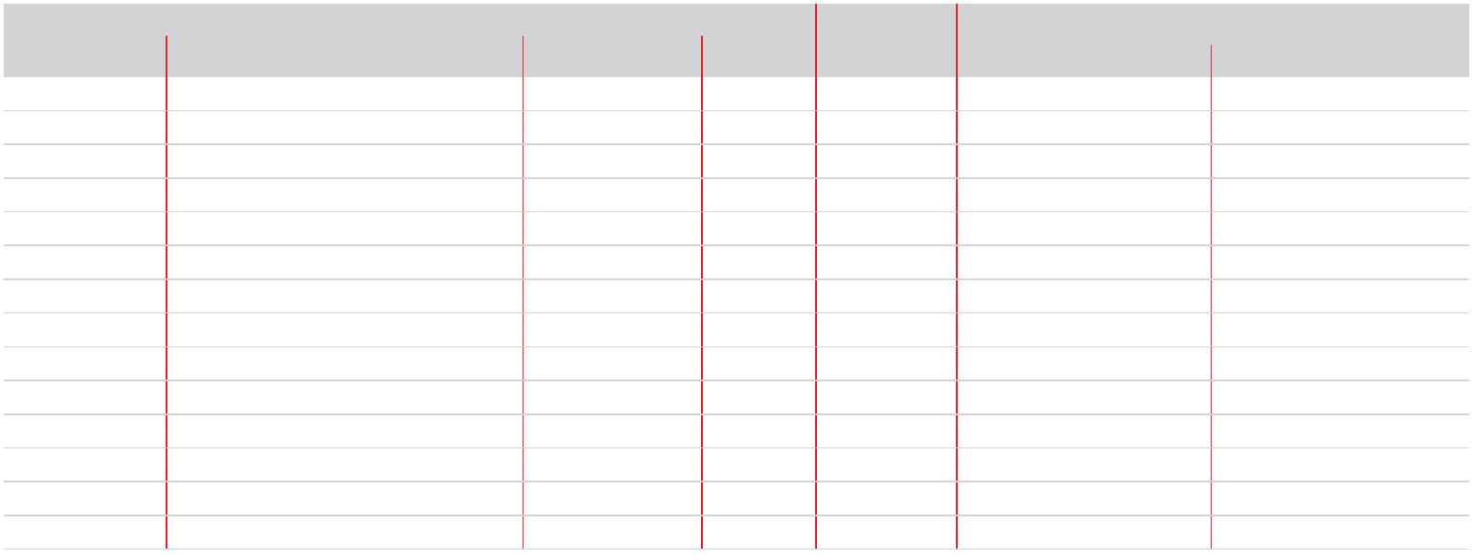Monoblock and Dual Block Gas FGR Burners
Available models
Gas Trains
GAS TRAIN VPS
ADAPTER CODE
CODE MODEL Ø CODE RS 800 RS 1000 RS 1200
20066263 / (20065924 +
3970221* MBC 1200/1 - RSM 60 Rp 2” 3010123 20042324 + 20064169 / (20068062)¹
20066263)¹
 |  |  |  |  | 3970222* MBC 1900/1 - FSM 40 DN 65 3010123 20059330 / (20065924 + 20059330)¹ /  (3010221 + 20059331)² |  |  |  |  |  |  |  |  | 20066263 / (20065924 +  20066263)¹
 |  |  |  | 3970223* MBC 3100/1 - FSM 40 DN 80 3010123 20059331 / (20065937 + 20059331)  (3010222 + 20059331)²  ¹ / |  |  |  |  |  |  |  |  | 20066268 / (20065937 +  20066268)¹
 |  | 3970224* MBC 5000/1 - FSM 80 DN 100 3010123 20059332 / (20065960 + 20059332)  (3010223 + 20059331)²  ¹ / |  |  |  |  |  |  |  |  |  | 20066278 / (20065960 +  20066278)¹
 |  |  |  |  |  |  | 3970147* CB 5065/1 - FSM 30 DN 65 3010123 20059330 / (20065924 + 20059330)  (3010221 + 20059331)²  ¹ / |  |  |  |  |  |  | 20066263 / (20065924 +  20066263)¹
 |  |  | 3970148* CB 5080/1 - FSM 30 DN 80 3010123 20059331 / (20065937 + 20059331)  (3010222 + 20059331)²  ¹ / |  |  |  |  |  |  |  |  |  | 20066268 / (20065937 +  20066278)¹
 |  |  |  |  |  | 3970149* CB 50100/1 - FSM 30 DN 100 3010123 20059332 / (20065960 + 20059332)  (3010223 + 20059331)²  ¹ / |  |  |  |  |  | 20066278 / (20065960 +  20066268)¹
 | 20015871* CB 50125/1 - FSM 30 DN 125 3010123 20059333 / (20065968 + 20059333)  (3010224 + 20059331)²  ¹ / |  |  |  |  |  |  |  |  | 20066284 / (20065968 +  20066284)¹
Please see designation of Gas Train Series in the page before the Catalogue index.
* 230V/50Hz -220V/60Hz electrical supply.
The valve seal control device is compulsory (conforming to EN 676) on gas trains to burners with a maximum output over 1200 kW.
The seal control function is managed by LMV control box, by installation on gas train of a pressure switch supplied, as standard equipment
with the burner.
To select the gas train please refer to the technical data leaflet and/or instruction manual. 1) To be used with gas train and burner opening on the left (fan motor side).
GAS TRAIN CQ KIT ADAPTER CODE
CODE MODEL Ø u CODE RS 1300 RS 1600 - 2000
3970223 MBC 3100/1 - FSM 40 DN 80 - 3010344 20130713 20130602
20093449 MBC 3100/1 CQ FSM 40 DN 80 CQ - 20130713 20130602
3970224 MBC 5000/1 - FSM 80 DN 100 - 3010344 20130602 20130616
20093452 MBC 5000/1 CQ FSM 80 DN 100 CQ - 20130602 20130616
3970149 CB 50100/1 - FSM 30 DN 100 - 3010344 20130602 20130616
20015871 CB 50125/1 - FSM 30 DN 125 - 3010344 20130606 20130617
20043047 DMV 50100/1 - FSM -0 DN 100 - 3010344 20130602 20130616
20043049 DMV 50100/1 CQ FSM -2 DN 100 CQ - 20130602 20130616
20043050 DMV 50125/1 - FSM -0 DN 125 - 3010344 20130606 20130617
20043052 DMV 50125/1 CQ FSM -2 DN 125 CQ - 20130606 20130617
20130030 VGD 40.80 DN 80 CQ - 20130713 20130602
20130031 VGD 40.100 DN 100 CQ - 20130602 20130616
20130032 VGD 40.125 DN 125 CQ - 20130606 20130617
20130033 VGD 40.150 DN 150 CQ - l 20130039
Please see designation of Gas Train Series in the page before the Catalogue index.
u Gas valve leak detection control device:
- gas train not equipped with leak detection control device; this device can be ordered separately - see VPS column -
and installed later.
CQ gas train with pressure switch for leak detection control of burners /E and /EV.
CQ KIT Additional pressure switch for leak detection control in combination with burners /E and /EV.
l Gas train not available or not suitable for the matching to the burner.
16
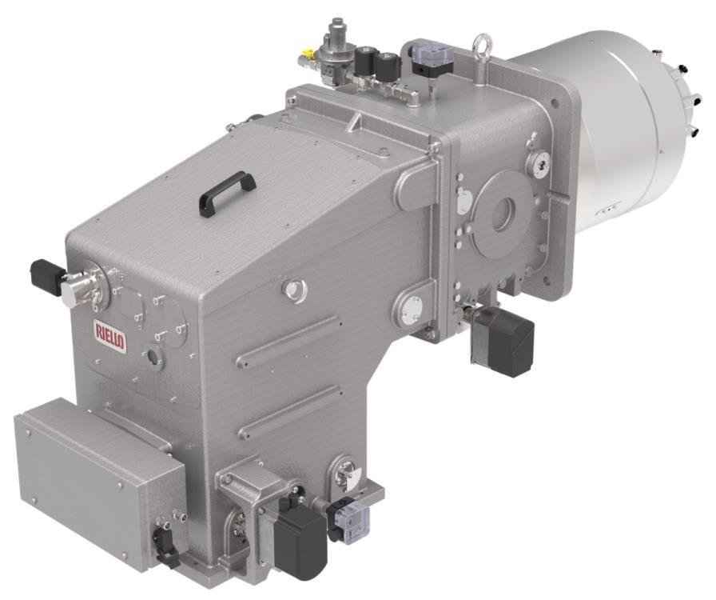Ultra Low NOx Gas FGR Industrial Dual Block Burners
DB SE FGR SERIES
In order to comply the increasing demand of very low NOx emissions, Riello has developed a new range of Dual-
block burners, the DB SE FGR series, from 2.500 to 16.000 kW, based on FGR (Flue gas Recirculation) low emission
technology, suitable to achieve extremely Low NOx emission performance, lower than 30 mg/Nm3.
The new DB SE FGR burners series represents the evolution in Riello Burners industrial product range; they are dual
block burners for application in big heating plants as well as in food, chemicals, textile industry for matching with
hot water boilers, steam and thermal oil generators.
DB SE FGR burners are supplied with electronic air-fuel ratio control in order to obtain a perfect output control
and to assure a correct low polluting combustion and a safe operation on all modulation range.
These burners models can work with pre-heated air up to 150°C as standard, up to 250°C with special construction.
As part of the offer, various accessories (air fan, control panels, high pressure gas train, etc) are available.
BURNER MODEL
DB 4 SE FGR 1000/2500 ÷ 4000 kW
DB 6 SE FGR 1400/4000 ÷ 6200 kW
DB 9 SE FGR 1500/5000 ÷ 7600 kW
DB 12 SE FGR 1700/7000 ÷ 10000 kW
DB 16 SE FGR 2500/8000 ÷ 12800 kW
DB 20 SE FGR 3000/10000 ÷ 16000 kW
17
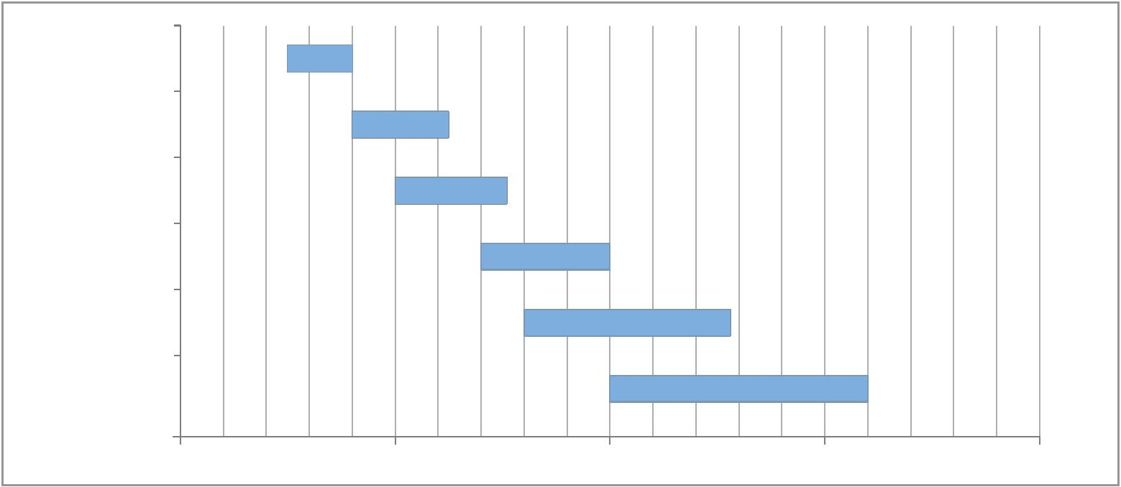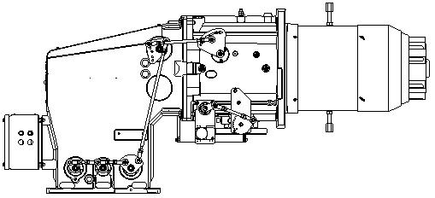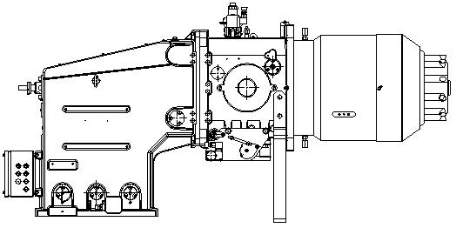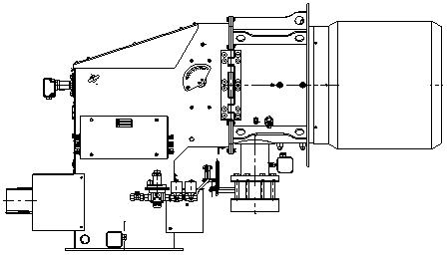Monoblock and Dual Block Gas FGR Burners
Firing Rates
DB 4 SE FGR
DB 6 SE FGR
DB 9 SE FGR
DB 12 SE FGR
DB 16 SE FGR
DB 20 SE FGR
 | - |  | kW  5.000 10.000 15.000 20.000
Test conditions conforming to EN 676
Temperature: 20°C Pressure: 1013,5 mbar
Altitude: 100 m a.s.l.
The burners of DB series can work with pre-heated air up to 150°C as standard, for high air temperature
applications up to 250°C, a special burner execution is required.
Gas Connections
 | DB 4: DN 65  DB 6: DN 80 |  | DB 9 - 12 DB 16 - 20
 | DN 65 gas connection from below  Elbow adapter DN 65 required  DN 80 gas connection from below (for  gas versions).  Elbow adapter DN 80 required. |  |  |  | DN 80 gas connection from below (for  gas versions).  Elbow adapter DN 80 required. |  | DN 100 gas connection from the side  Elbow 100/100 adapter already included  as standard equipment
18
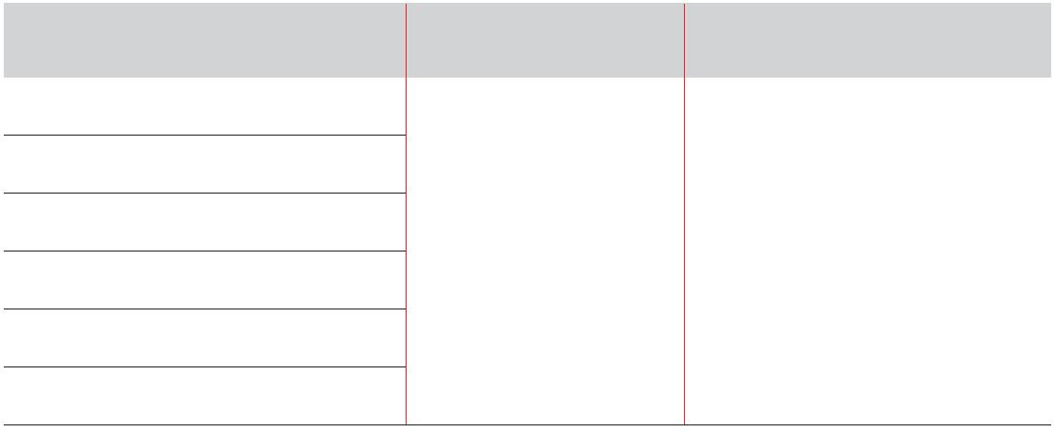Specification
STATE OF SUPPLY
Dual block forced draught, Ultra Low NOx gas burner with Flue Gas Recirculation (FGR) system, with modulating
operation, fully automatic, made up of:
- Air damper for air setting controlled by a high precision servomotor
- Air pressure switch
- Low emission combustion head, that can be set on the basis of required output, fitted with:
- stainless steel end cone, resistant to corrosion and high temperatures
- flame stability disk
- Automatic regulator for gas delivery, controlled by a high precision servomotor
- Burner Pilot Ignition system, with dedicated gas train, to assure a high ignition reliability
- Flue gas recirculation butterfly valve controlled by a high precision servomotor (separate from the burner)
- Flue gas recirculation temperature probe to prevent condensation in burner intake
- Maximum gas pressure switch, with pressure test point, to stop the burner in the case of excess pressure on
the fuel supply line
- Electronic Cam control
- for air/fuel setting
- for output modulation with incorporated PID control of temperature or pressure of the heat generator
- with indication of operating status and parameters, error messages and diagnosis of fault causes
- Operator panel with LCD Display Interface, for combustion system commissioning and monitoring
- Burner safety control included on Electronic Cam device
- UV sensor for flame detection
- Electrical interface box with ignition transformer inside - Lifting rings
Available models
Burners
MODEL OPERATION FUEL
DB 4 SE FGR
DB 6 SE FGR
 | DB 9 SE FGR  DB 12 SE FGR |  | MODULATING WITH  ELECTRONIC CAM
NATURAL GAS
DB 16 SE FGR
DB 20 SE FGR
For more information about product codes, please contact Riello Burners Commercial and Technical
Department, our Application Engineers will be pleased to help you.
19
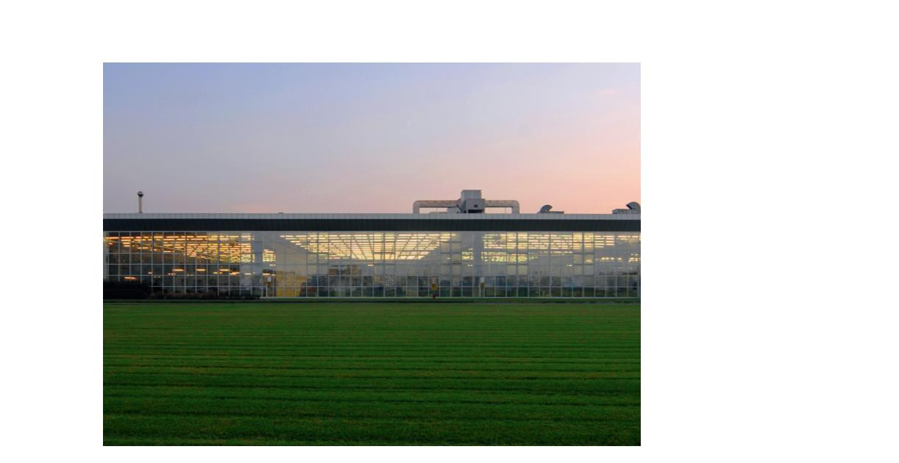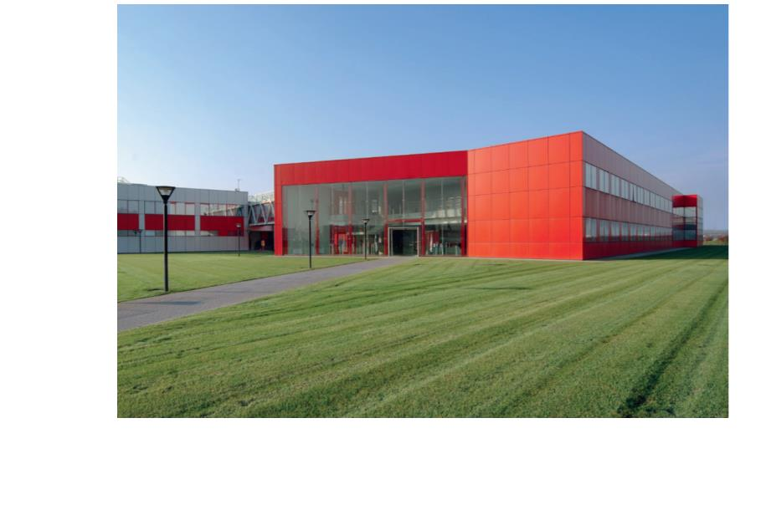Riello Burners a world of experience in every burner we sell.
Across the world, Riello sets the standard in reliable and
high efficiency burner technology.
With burner capacity from 5 kW to 48 MW, Riello gas,
oil, dual fuel and Low Nox burners deliver unbeatable
performance across the full range of residential and
commercial heating applications, as well as in industrial
processes.
With headquarter in Legnago, Italy, Riello has been
manufacturing premium quality burners for over 90 year.
The manufacturing plant is equipped with the most
innovative systems of assembling lines and modern
manufacturing cells for a quick and flexible response to
the market.
[ 1 ]
Besides, the Riello Combustion Research Centre, located in
Angiari, Italy, represents one of the most modern facility
in Europe and one of the most advanced in the world for
the development of the combustion technology.
Today, the company’s presence on worldwide markets is
distinguished by a well-constructed and efficient sales
network, alongside many important Training Centres
located in various countries to meet its customers’ needs.
Riello has 13 operational branches abroad (in Europe,
America and Asia), with customers in over 60 countries.
[ 2 ]
[ 1 ] |  |  | BURNERS PRODUCTION PLANT  S. PIETRO, LEGNAGO (VERONA) - ITALIA
[ 2 ] |  |  |  | HEADQUARTER BURNERS DIVISION  S. PIETRO, LEGNAGO (VERONA) - ITALIA
RIELLO S.p.A. - 37045 Legnago (VR) - Italy
tel. +39 0442 630111 - fax: +39 0442 21980
www.riello.com
Since the Company is constantly engaged in the production improvement, the aesthetic
and dimensional features, the technical data, the equipment and the accessories can be
changed. This document contains confidential and proprietary information of RIELLO S.p.A.
Unless authorised, this information shall not be divulged, nor duplicated in whole or in part.

